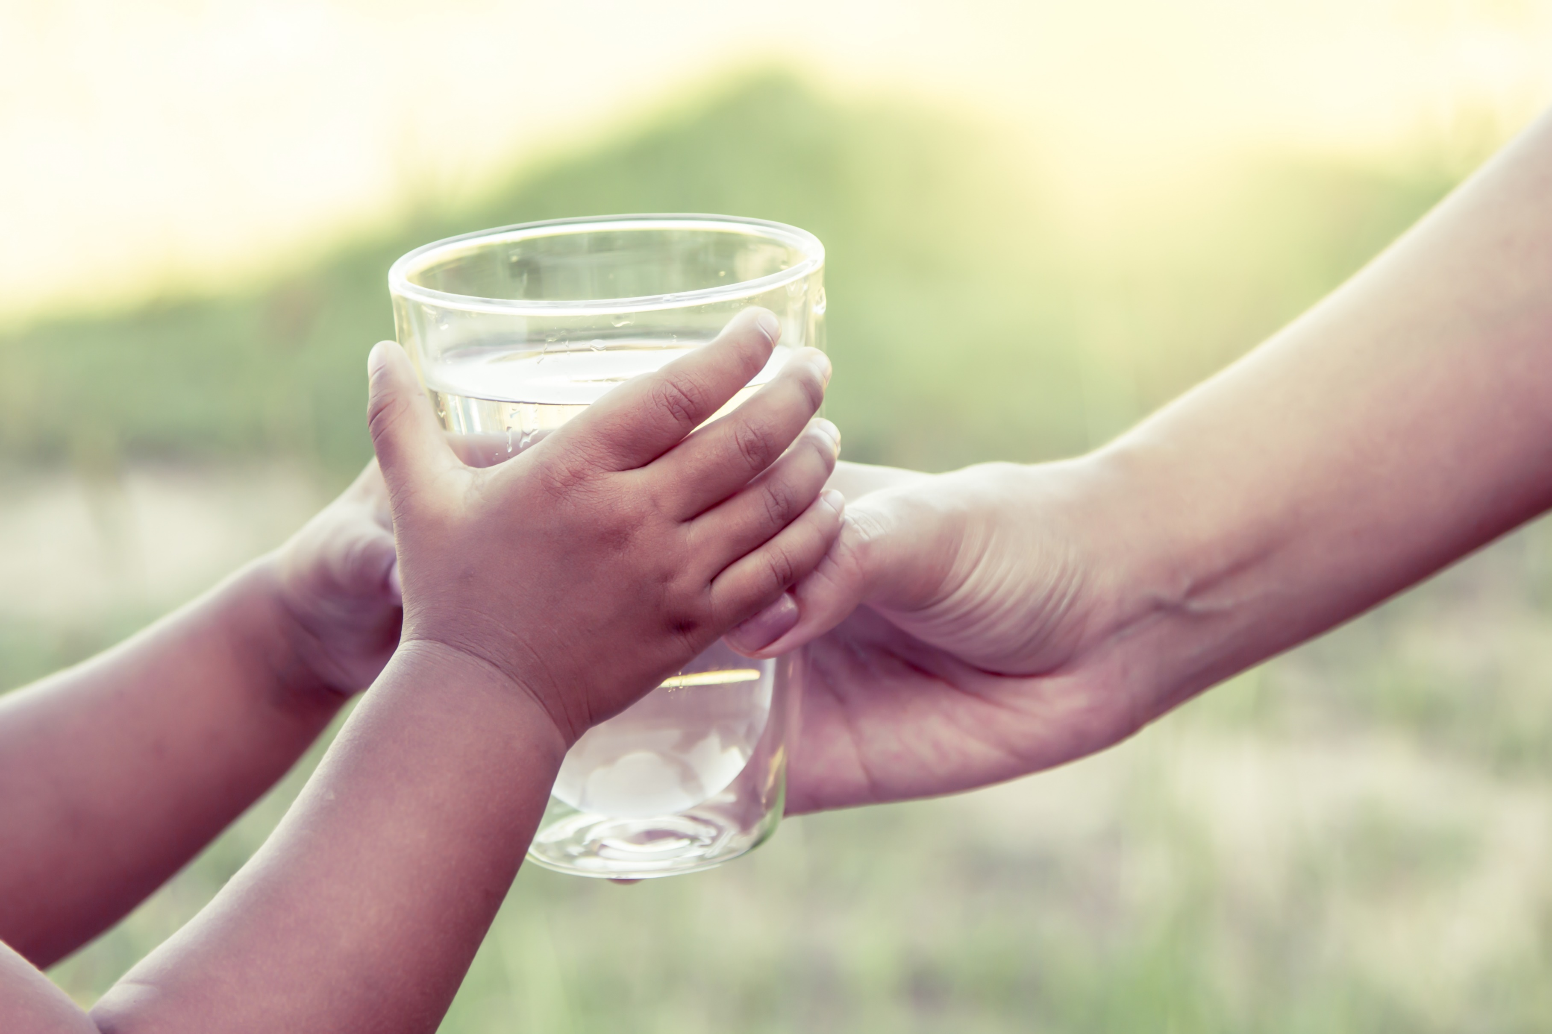

Wisconsin WellTAP

Acute Risk

Response Guide

# Table of Contents

|  |  |
| --- | --- |
| Instructions | 1 |
| Script 1: Bacteria detection | 2 |
| Script 2: Elevated nitrate | 3 |
| Script 3: Elevated manganese | 4 |

Instructions

1. Identify the appropriate script language:

|  |  |
| --- | --- |
| **Substance(s) of Concern** | **Script** |
| Total coliform (and *E. coli*) bacteria present | 1 |
| Nitrate equal to or greater than 10 mg/L | 2 |
| Manganese equal to or greater than 300 μg/L | 3 |

1. Determine contact method: email or phone call.
2. Provide the appropriate information highlighted in blue.
3. Follow the actions described in gray.
4. Contact the well user.

Script 1: Bacteria

Hello,

I am calling/writing from the AGENCY to share some of the results from the testing of your private well collected on DATE.

The results show that [total coliform (AND E. coli)] bacteria arein the water. This means that your well water may be contaminated with human or animal waste or other harmful bacteria.

Because of this, we recommend that you stop using your water for drinking, rinsing fruits and vegetables, brushing teeth, and bathing babies.

We recommend that you use a different source of water for these activities. This could be water that you boiled for one minute, bottled water, water from a well without issues, or water from a public water system.

I will email/mail/have attached a fact sheet that describes these steps and more in detail. [Email/print/attach copy of [DHS' Bacteria in Private Well Water fact sheet](http://www.dhs.wisconsin.gov/publications/p02132.pdf)]

To double-check these results, we are mailing/dropping off/making available a second bacteria test kit. When collecting this sample, be sure to follow the sample instructions closely. Be sure not to touch the inside of the bottle or the cap.

When we have the results of the remaining tests, we will email/mail them to you along with a letter that summarizes the findings.

If you have any additional questions after today, please feel free to contact me at email or phone number.

Thank you (email),

Goodbye (phone call).

Script 2: Nitrate

Hello,

I am calling/writing from the AGENCY to share some of the results from the testing of your private well collected on DATE.

The results show that the nitrate level in your water is above the public health value of 10 milligrams per liter. Because of this, people who are or may become pregnant should stop using the water for drinking and making foods that take up lot of water (like rice, oatmeal and gelatin) as soon as possible. We also recommend that you stop using the water to make baby formula and stop giving it to babies to drink as soon as possible.

We recommend that you use a different source of water for these activities. This could be bottled water, water from a well without issues, or water from a public water system.

I will email/mail/have attached a fact sheet that describes these steps and more in detail. [Email/print/attach copy of [DHS' Nitrate in Private Well Water fact sheet](https://www.dhs.wisconsin.gov/publications/p02128.pdf)]

To double-check these results, we are [mailing/dropping off/making available] a second nitrate test kit. When collecting this sample, be sure to follow the sample instructions closely.

When we have the results of the remaining tests, we will email/mail them to you along with a letter that summarizes the findings.

If you have any additional questions after today, please feel free to contact me at email or phone number.

Thank you (email),

Goodbye (phone call).

Script 3: Manganese

Hello,

I am calling/writing from the AGENCY to share some of the results from the testing of your private well collected on DATE.

The results show that the manganese level in your water is above the public health value for sensitive populations of 300 milligrams per liter. Because of this, people over the age of 50 should stop using the water for drinking and making foods that take up lot of water (like rice, oatmeal and gelatin) as soon as possible. We also recommend that you stop using the water to make baby formula and stop giving it to babies to drink as soon as possible.

We recommend that you use a different source of water for these activities. This could be bottled water, water from a well without issues, or water from a public water system.

I will email/mail/have attached a fact sheet that describes these steps and more in detail. [Email/print/attach copy of [DHS' Manganese in Private Well Water fact sheet](https://www.dhs.wisconsin.gov/publications/p4/p45103a.pdf)]

To double-check these results, we are [mailing/dropping off/making available] a second nitrate test kit. When collecting this sample, be sure to follow the sample instructions closely.

When we have the results of the remaining tests, we will email/mail them to you along with a letter that summarizes the findings.

If you have any additional questions after today, please feel free to contact me at email or phone number.

Thank you (email),

Goodbye (phone call).