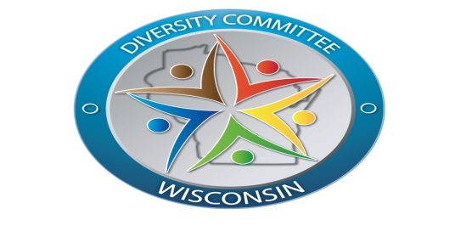
Diversity Committee

Mission
To enhance and honor the lives of Diverse Populations of Wisconsin by providing access to cultural intelligent substance use disorders that are related services.

Objectives
- To identify, coordinate, review, and promote the use of existing best practice for programs providing substance use disorders and co-occurring disorders for the underserved populations.
- To identify unmet needs of underserved populations.
- To develop action steps to bridge identified gaps for unmet services.

