managed care rule tagline
Use the tagline that corresponds with your requirements. You will need fonts installed on your computer for the following languages: Burmese and Laotian. Type your phone number and TTY number in the spaces provided.
Taglines must be conspicuously visible.
English
ATTENTION: If you speak English, language assistance services are available to you free of charge. Call TTY:

Spanish
ATENCIÓN: Si habla español, los servicios de asistencia de idiomas están disponibles sin cargo, llame al TTY:

Hmong
CEEB TOOM: Yog koj hais lus Hmoob, kev pab rau lwm yam lus muaj rau koj dawb xwb. Hu TTY:

Chinese Mandarin
注意：如果您说中文，您可获得免费的语言协助服务。请致电 TTY 文字电话:
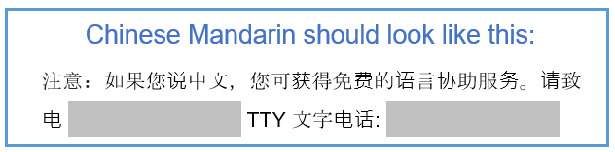
Somali
DIGTOONI: Haddii aad ku hadasho afka Soomaaliha, adeegyada caawimada luqadda waxaa laguu heli karaa iyagoo bilaash ah. Wac TTY:

Laotian—must turn off show/hide button (¶) in Home tab
ໝາຍ​ເຫດ: ຖ້າ​ທ່ານ​ເ​ວົ້າພາສາ​ລາວ, ທ່ານ​ສາມາດ​ໃຊ້ການ​ບໍລິການ​ຊ່ວຍ​ເຫຼືອດ້ານ​ພາສາ​​ໄດ້​ໂດຍ​ບໍ່​​ເສຍ​ຄ່າ. ​ໂທ TTY:
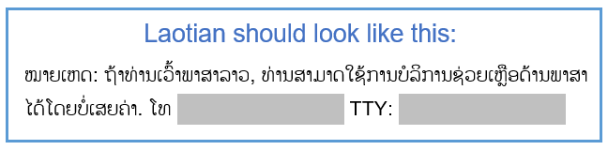

Russian
ВНИМАНИЕ: Если Вы говорите по-русски, Вам будут бесплатно предоставлены услуги переводчика. Позвоните по номеру: TTY:

Vietnamese
LƯU Ý: Nếu bạn nói tiếng Việt, các dịch vụ hỗ trợ ngôn ngữ sẽ được cung cấp miễn phí cho bạn.
Gọi TTY:
Burmese
ေက်းဇူးျပဳ၍ နားဆင္ပါ - သင္သည္ ျမန္မာစကားေျပာသူျဖစ္ပါက၊ သင့္အတြက္ အခမဲ့ျဖင့္ ဘာသာစကားကူညီေရး ၀န္ေဆာင္မႈမ်ား ရရွိနိုင္သည္။ TTY: တြင္ ဖုန္းေခၚဆိုပါ။
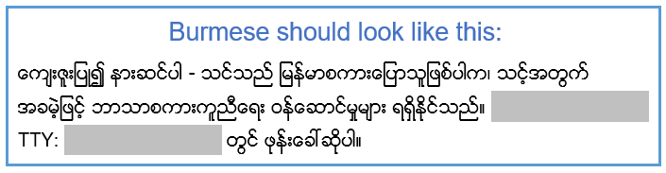

Arabic (right to left)
تنبيه: إذا كنتم تتحدثون العربية، تتوفر لكم مساعدة لغوية مجانية. اتصلوا بالرقم هاتف نصي:
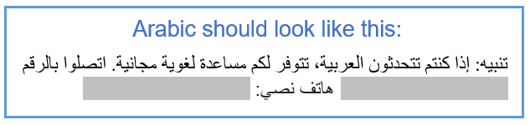
Serbo-Croatian
PAŽNJA: Ako govorite srpsko-hrvatski imate pravo na besplatnu jezičnu pomoć.
Nazovite telefon za gluhe:

