WEDSS new user training

For CMR version 15, revised May 2, 2016

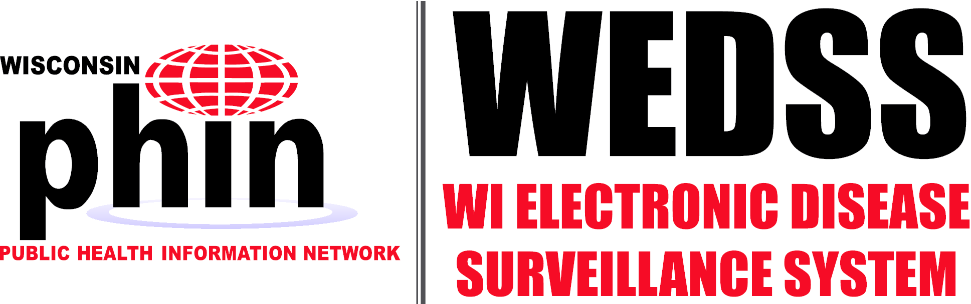

# Contents

Contents 1

Training Information 2

Course Description 2

Your accounts and patients today 2

Case Load and Searching 3

Your case load 3

How to find a report that isn’t on your case load 4

Perform a Person Search 4

Perform a Disease Incident Search 5

Unmasking 6

Print All Web Report View 8

Web Report FAQs 9

Previous search 10

Using jurisdiction review 11

ARNOLD Alerts 14

Reporting New Incidents 15

Avoiding duplication 15

Creating a new person and disease incident 15

Filling out a disease incident report 18

Automatic Disregarding of Unknown Race 23

Reported Race FAQs 24

Creating a contact investigation 25

Animal Reports 27

Outbreaks 28

Group events 29

Merging 30

Patients 30

Disease Incidents 34

Hospitalization Information 37

Hospitalization Information FAQs 38

The staging area 39

An overview of staging 39

Finding records and checking that they’re current 40

Comparing patients’ demographics 40

Basic Workflow 40

Never attach a web report! 41

Updated Demographic Import Options 42

Practical exercises 44

# Training Information

## Course Description

In this session, we will provide new user training on the core functionality of disease surveillance in WEDSS, and include the changes in functionality in the WEDSS version 15 upgrade to be released on April 4, 2016. This course is strongly recommended for WEDSS users who are new to WEDSS, have not had prior training, or would like to re-learn the fundamentals. We will cover the core functionality of WEDSS. Training on staging will comprise about half of the session and includes training on the most significant changes in the upcoming version of WEDSS.

In this session, you will gain the necessary skills and knowledge to fully use WEDSS for disease surveillance. There will be portions of training where an instruction is given without explicit instructions for completing it. In these situations, use what you have learned or what you already know, and feel free to ask for help if you get stuck.

## Your accounts and patients today

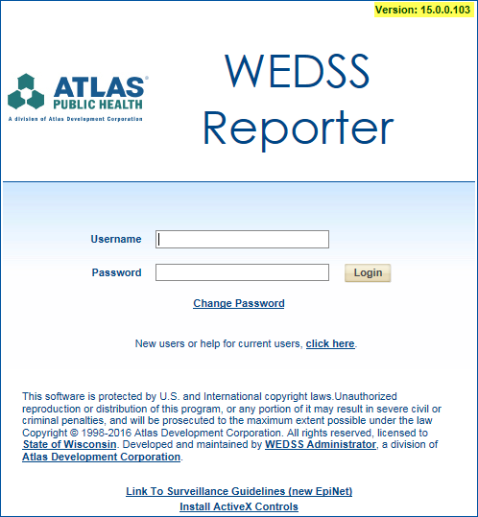Please refer to the handout with your account information and the names of the fake patients you will be working with in this session. Enter your username and password to log in.

# Case Load and Searching

## Your case load

The most noticeable update to your Case Load is that now, once a case has a process status set to a state-related status or final, it will automatically drop off your Case Load.

1. Navigate to My Case Load. This should be the first screen you see after you log in to WEDSS.
2. 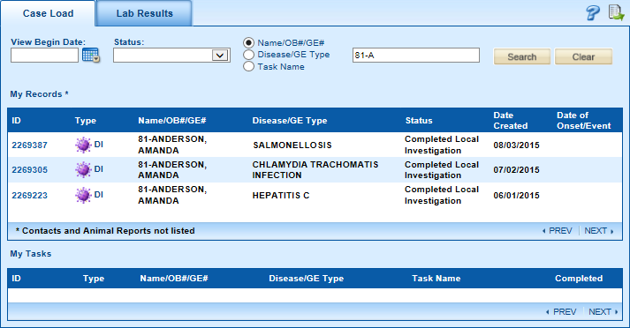Use the search boxes at the top to search for your Patient A. Can you find where you’d search for somebody by name? Remember, your patient will have a number before their name that should correspond to your handout.
3. From your caseload, you should see the name of your Patient A (refer to your handout). To see what happens when an incident’s record is sent to a state-level or finalized processed status, open Patient A’s Salmonellosis disease incident by clicking on its ID , which will bring up the incident report. Within the report, navigate to the investigation tab at the top.
4. 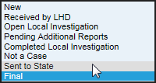Change the process status to Sent to State and press  in the lower right corner of the form. When you return to your caseload, you’ll see that the case has been removed from your case load; that will happen whenever anybody changes the process status. If a state staff member changes the process status to “returned to LHD,” it will reappear in your case load.

## How to find a report that isn’t on your case load

Should you need to find a record once it has fallen from your caseload, you can search for it within the system either through the Search screen or Jurisdiction Review. Typically, it is easiest to search either by Name or by Disease Incident ID.

### Perform a Person Search

To search for somebody by name, navigate to the tab, open to the Person tab, enter their name as LAST, FIRST, and press find. We recommend that you use the first three characters of a patient’s name only, this way if there are incorrect or alternative spellings, it will find all patients whose names begin with the same three characters.

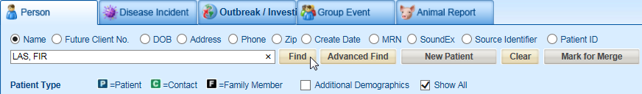

For example, if searching for somebody called BENJAMIN WISEMAN who was entered into the system as BEN WISEMIN, you will not find them by looking for WISEMAN, BENJAMIN. You would, however, find them by searching for WIS, BEN—you would also find somebody if they were named something like BENEDICT WISELY.

If you were to search for someone who has dozens of name matches (e.g., a very common name), searching by DOB can bring up a much smaller list on which your target is the only one with their particular name. Another useful option is the Patient ID, which is useful in situations where you have a person with contacts and contact investigations in other jurisdictions; searching for the index case by Patient ID will find them. Medical Record Number (MRN) searches can be useful for finding patients by provider number.

If you wish to find a patient by their secondary information, select the Additional Demographics checkbox. You can use the Show All check box to display all versions of a person.

You can also unlock out-of-jurisdiction records via the  button. You may do this when you have a good reason to do so, all incidents you unlock will be recorded and audited.

***Note: The search screen is the only place where records can be marked for merge (which we will cover later on).***

### Perform a Disease Incident Search

To search by disease incident, move over to the Disease Incident tab and enter the Record ID Number. If you’re unsure of the last few characters, you can also enter a % to pull up all records that have an ID number matching what you have entered. If you are missing a specific character within the number, you can enter a % to allow any permutation of that specific character. Searching by record ID is useful as the ID numbers are system specific and may be emailed to colleagues without identifying your patients.

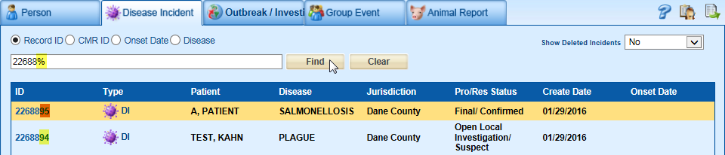

### Unmasking

Records are restricted by disease and jurisdiction groups to limit what users are able to access to certain records. Records you do not have access to are ‘masked.’ On occasion, a user from a different jurisdiction would need to access a currently ‘masked’ record. When ‘unmasking’ you will gain access to the records that you have permission to see (i.e., within your disease access*). Unmasking is done on a person-by-person basis.

Example.

1. Go to the person search screen
2. Search for the person, Zapatos, Zooey, to access their records.

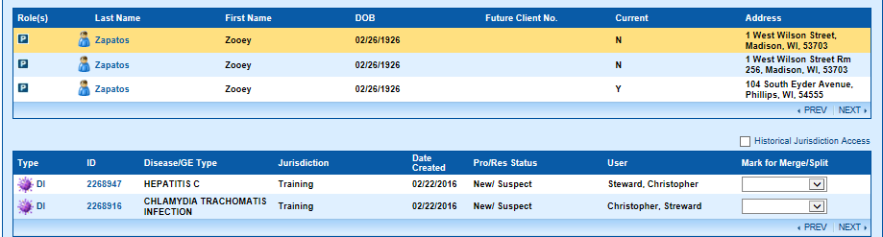

1. You will see a message that there are additional records that you are not able to see. Click the Unlock button.



1. A popup will appear asking for a reason why you need to unlock this person record.
   1. Select a reason from the dropdown and add a comment if you so choose.
   2. Click OK.
2. The search screen will refresh with the previously unavailable record

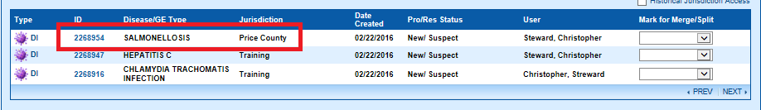

1. You can now access this record and edit it as if it was assigned to your jurisdiction.

**\*Any disease incident outside one’s access will not show up or give the masked records message; you will not be informed of its existence.**

**Try performing some searches now.**

1. Try searching for a test patient within the system. Let’s look for someone named Vidarr Valhalla. Try entering “Val, Vid” to find all patients with a surname beginning with “VAL” and a first name beginning with “Vid.”
2. How many people can you find born in the last year? Select DOB, and type t-365 in the From box and t in the To box.
3. How many people from the Targaryen family can you find?
4. How many disease incidents can you find with an onset date within the last year?

## Print All Web Report View

Purpose: View all the tabs and case reports from a provider-submitted Web Report after it has been imported.

***Steps***

1. Click on Search in the top navigation menu.
2. Enter the first three letters of the last name, then the first three letters of the first name. ZAP, ZOO (and locate Chlamydia Case for Zapatos, Zooey). Then select Find.
3. Select the ID to view the record.
4. Click on the Filing Cabinet Icon.

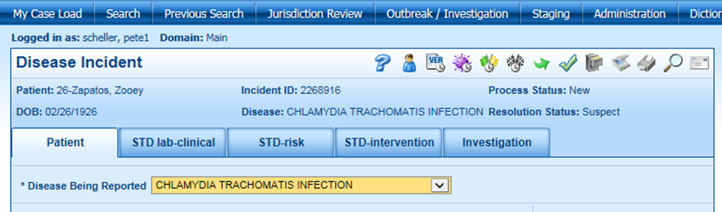

1. From within the filing cabinet, press a Web Report.

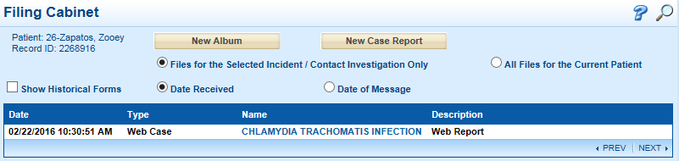

**Note:** All Case Reports (UDFs) are included in this View, whether they are disease-specific tabs or attached in the filing cabinet.

1. Close the Web Report.
2. Close the Filing Cabinet.

## Web Report FAQs

1. What happens if I try to open a Live Disease Incident while the PDF is being produced?

*In this scenario, the following standard locked record functionality is followed:*

* + *The record is opened in read-only mode.*
  + *The red text alert at the top of the page is displayed as: “This record is locked by a system process.”*
  + *A Message Alert dialog is displayed with the following text: “The record {Record ID} is currently locked by a system process. <OK>.”*

*Clicking OK closes the dialog and leaves the user on the read-only record.*

*If the lock is released while the system user still has the locked record open, when the page refreshs a Message Alert witll appear: “You have acquired the right to edit this incident. The incident will be refreshed to load the latest saved information. <OK>.”*

*Clicking OK closes the dialog and the page is refreshed.*

1. What is the difference between a Web Report and a Web Case?

*If a Web Report submitted by a provider is the report responsible for the creation of the Disease Incident in Live, then its Type is “Web Case.” All other reports subsequently attached to the Disease Incident are of the Type “Web Report.”*

1. How do I create a PDF file instead of printing a hard copy of the report?

*The print option will currently print to your default printer. If you want to create a PDF file instead, access “Control Panel” on your computer and change the default print to the PDF printer instead. A future update will allow you to choose the printer within WEDSS.*

1. Are reports uploaded by local public health or state staff included in the print all by default?

*No, reports uploaded by local public health or state staff are not included in the print all by default. A future update will also address this concern.*

### Previous search

Returning to your last search can be done by navigating to , which will return to the last search performed from:

* Case Load
* Person Search
* Disease Incident Search
* Outbreak Search
* Group Event Search
* Animal Report Search
* Jurisdiction Review.

Note that this will only go back to the single last search—you cannot use it to navigate backward continuously.

# Using jurisdiction review

Jurisdiction Review houses the most specialized search features, which, combined with the export feature, can help you to manage your workload and patient history. Let’s go over a few examples of how Jurisdiction Review can be helpful.

1. Navigate to Jurisdiction Review; you’ll be presented with a list of all reports within your jurisdiction(s). To see only reports on which you are an investigator, click on the Investigator dropdown, select your name, and click on Find.

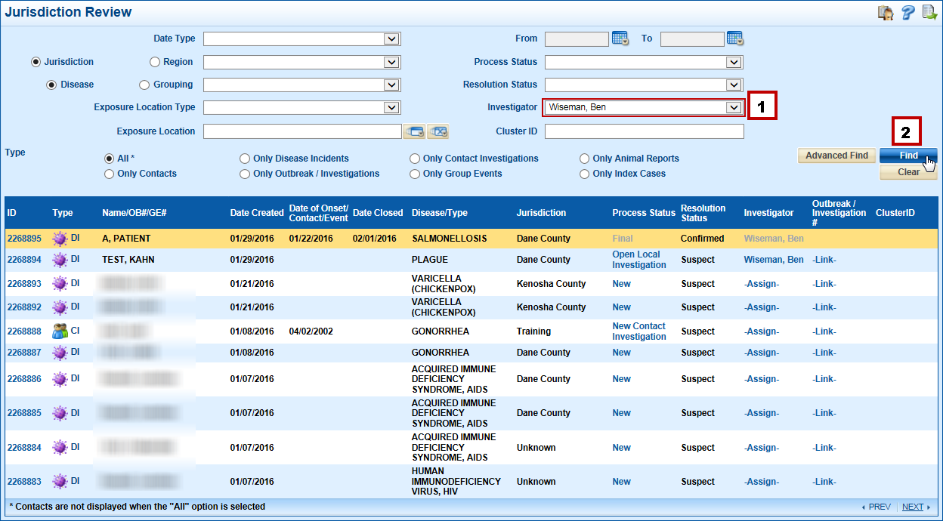

Doing so will filter the list of reports down to your specific cases



1. You can also use multiple filters at the same time. Press  and **try searching for all of your cases that have a Date of message from between July 31, 2015, and today.**

*Hint: Remember to select a* Date Type*.* *Also*, *typing* t *in a date field will automatically bring up today’s date as soon as you leave the date box.*

There is also an Advanced Find feature; you can use this to find cases under much more specific conditions.

1. Let’s **try to find all cases of** Hepatitis C **where** form the HepC Lab Clinical tab, section Laboratory Information has a Hepatitis C antibody Test (code **5198-7**).

*Note the  and  buttons, which enable you to add more terms to the filter to narrow your results. Multiple search conditions are searched for with AND logic meaning it will only search for cases where all terms (1 AND 2 AND 3… ) are met.*

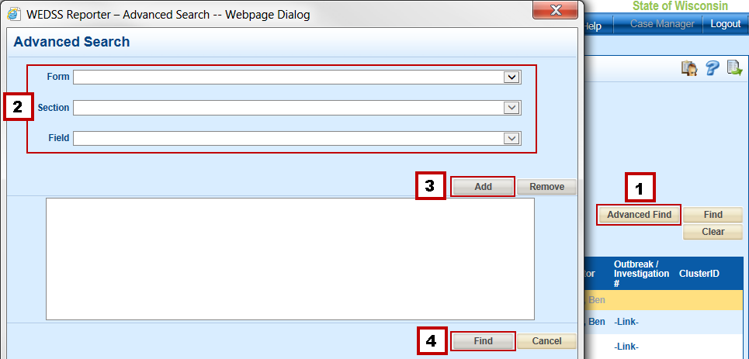

1. Go back to the main Jurisdiction Review screen and search for all Pertussis cases. Did anything show up? Take a look at the text just above the results list. Can you see why no Pertussis cases were found?

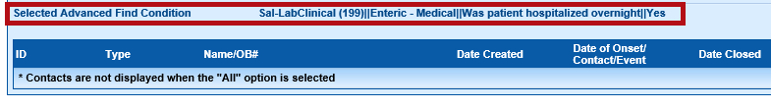

1. Press  and try searching for Pertussis again. Did it work this time?
2. If you want to move a list of your cases into Excel (or other spreadsheet viewers), simply click on the **export** button  to bring up a window of options for exporting the data, select the fields you want to have in the spreadsheet, and press 

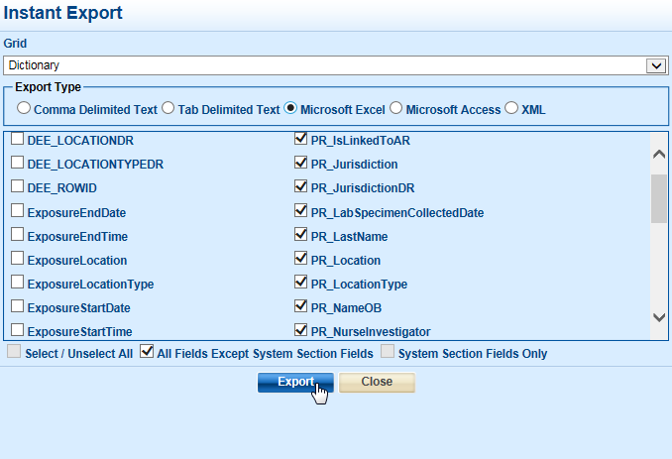

Note that Microsoft Access format is required to export some fields.

# ARNOLD Alerts

ARNOLD is an automated alert system that allows you to receive notifications about specific diseases and reports directly to your inbox. In CMR15, it is now possible to have lab results display in the Alerts.

**How the lab information is formatted for email:**

[ResultDate] [ResultedTest]: [Result] [Units] [Resulted Organism]

**Look at the below example – can you see how the above format is implemented?**

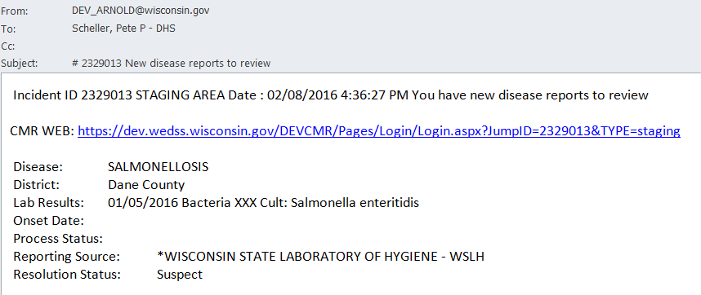

ARNOLD can also give you alerts when

* A new record appears in staging [Recommended]
* A new record is imported or directly entered into the system. [Recommended]
* A record is in any way modified [Not Recommended]
* A report has content added to the filing cabinet [Sometimes Recommended]
* A record’s process status changes [Sometime Recommended, e.g. returned to LHD]

To get ARNOLD alerts set up, email the WEDSS team at [dhswedss@wisconsin.gov](mailto:dhswedss@wisconsin.gov) and let us know what kind of alerts you’d like. We’ll take care of the rest for you. For additional documentation, reference the ARNOLD document on the WEDSS Sharepoint site.

# Reporting New Incidents

Although most of the reports you receive likely come through staging because they were either electronically transmitted from a laboratory or entered into the system by a provider, you may still receive paper reports of communicable diseases. You can hand enter reports directly into WEDSS. However, since reports that are entered by LHD staff do not go through staging, it is important to follow a few steps to avoid creating duplicate data in the system.

## Avoiding duplication

The simplest way to avoid creating duplicate patient records in WEDSS is to perform a person search  and attempt to find a matching patient record. Be sure to use a truncated search with the first few characters of the patient’s first and last name only.

Make sure you try a few searches, like a DOB and name search, before creating a new incident or person.

***Note****: the option to create a new patient is locked until you perform a search*

## Creating a new person and disease incident

1. Search for your patient B—you should be able to find them in the system relatively easily.

**Let’s make a mistake**—we’ll fix it later. You should see patient B in the list of people returned by your search. Normally, we’d press to add a new incident to the existing patient.

1. Take a note of your patient’s DOB and then **Pretend we didn’t see the person and press** , which will create a new patient.
2. You should now be presented with a form on which you can enter patient information, enter the information for your patient B. Don’t worry about filling in their precise demographics, after all, we are pretending to make a mistake.

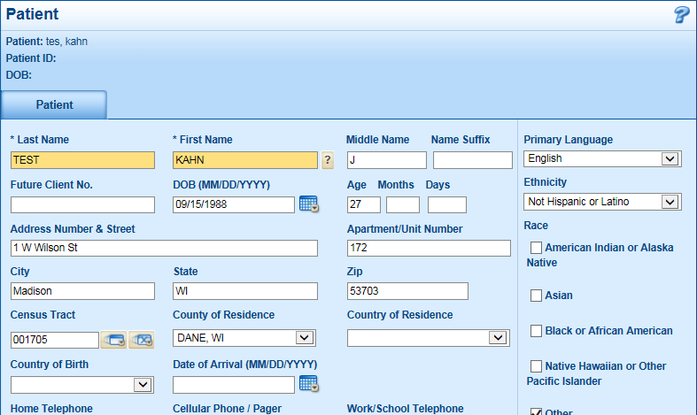

Something important to note when filling out a patient’s demographic information: the Census Tract. An incorrectly formatted address will cause the system to place the patient in the Unknown jurisdiction. To check that your address is properly formatted, click the  button beside the Census Tract field. If you have entered the address correctly, it will display the geographic information:

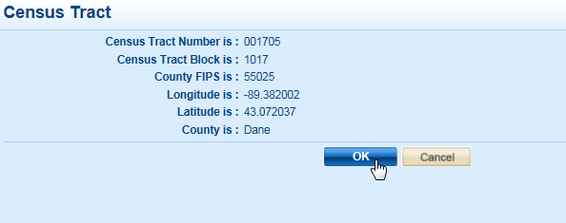

If the latitude and longitude is displayed as NA, the address is not properly formatted or cannot be found. Try searching for the address on Google or Bing, usually they will suggest the correct address format. An example of the correct format would be 8017 State Highway 101, Armstrong Creek, WI, 54104 St as opposed to 8017 WI-101, Armstrong Creek, WI, 54104.

**Some addresses may simply not geocode. If you’ve tried several ways and still can’t find it, manually set the Jurisdiction of the disease incident and get in touch with the WEDSS program.**

After filling out the yellow (mandatory) fields, fill out some other fields with something imaginative that you’ll recognize as your own later on. When you get to the bottom of the form, click on the New Incident button to create a new disease incident.

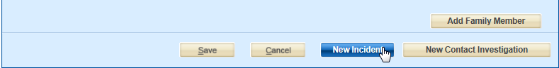

***Note****: to create a contact investigation, you’d click the* New Contact Investigation *button. Don’t worry about adding family members.*

**You should now have a blank disease incident form on screen.**

You can identify a disease incident by the “Disease Incident” label in the top left and the process status options on the Investigation tab.

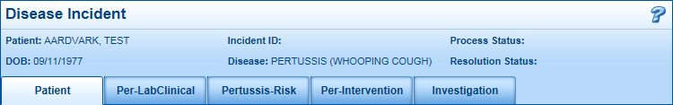

## Filling out a disease incident report

Now that we have entered our patient (remember, we are deliberately making a duplication mistake), let’s add a disease.

1. In this case, use the Disease Being Reported Field to give Patient B a case of PERTUSSIS. After setting the disease field, other tabs related to pertussis will appear.

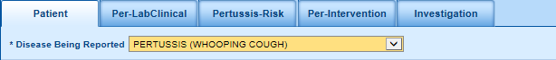

When filling out disease forms, remember that any field in yellow must be filled out to submit the incident, and you should add as much information as you can to the other sections. Some forms will have specific fields highlighted in red text. For any form that has a field, those are especially important to fill in. We ask that you do not use note fields to store important information such as lab results, risk factors, and prescription information. When filling out sections, you can use the  button to open and close *all* fields as well as the  button to open and close all *empty* fields.

1. Go ahead and add the following:
   1. Since the patient tab should already have data in it, navigate to the Per-intervention tab (you can either click on the tab or use the Next button at the bottom to go to the next tab).
   2. Fill out the Attempts to Contact section and click  when you’re done. What happens when you add data?

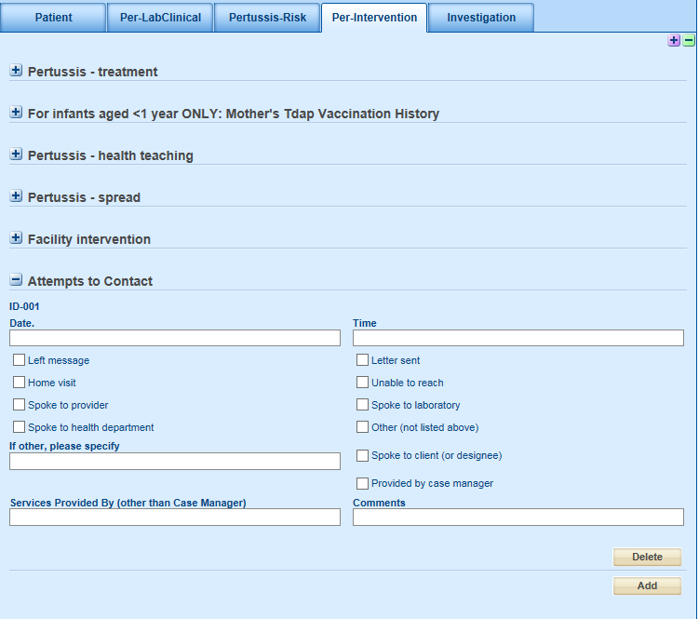

* 1. Proceed to the Contacts (system) section and press  to add a contact.

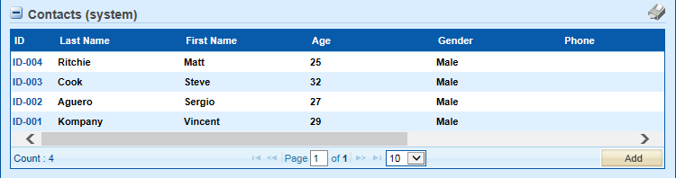

You’ll notice that this segment looks quite different compared to the Attempts to Contact section. This new type of section is called a Grid View and is new to version 15. The Grid View is designed to significantly reduce clutter on forms.

* 1. You should see a popup screen, click on Link Patient and search for your patient A. Add the most current version if applicable.

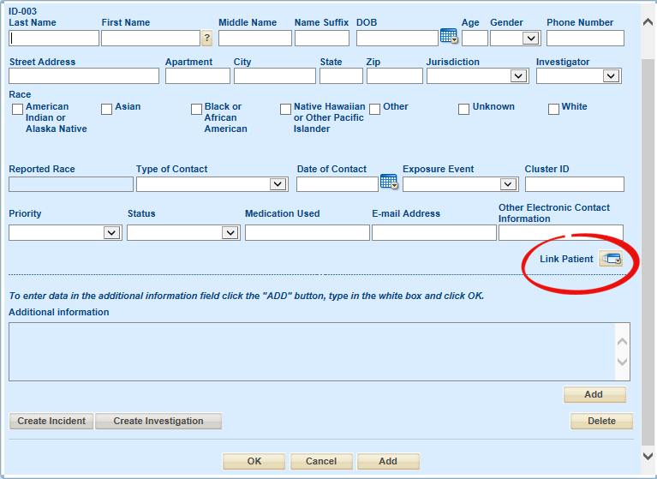

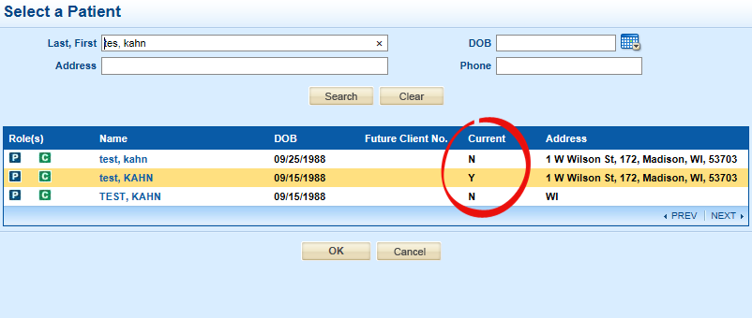

* 1. You can search by name, address, DOB, or phone number. If the patient does not currently exist in the system, press cancel and use the fields on the contact widget to enter their information.

Be sure to set the Jurisdiction before progressing.

* 1. Once selected, click Add and then OK

1. Click Save to remove any blank lines in the Grid View.

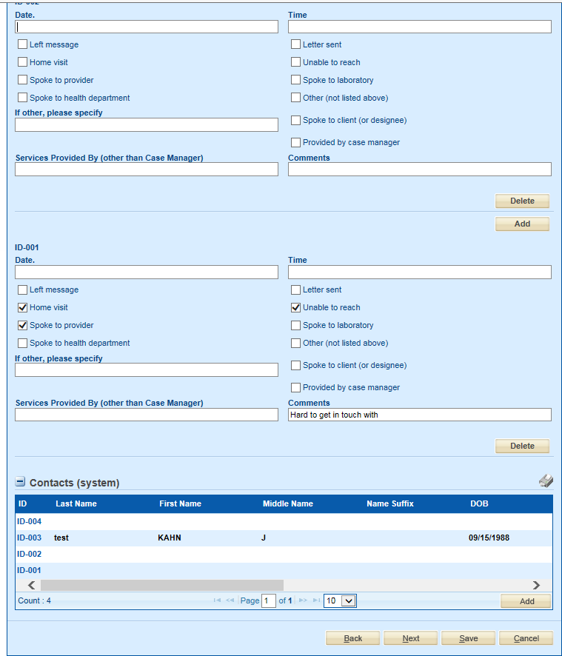

1. Press  and move on to the Investigation tab. If you save your work as you go, you don’t need to worry about getting called away on something urgent and having the system time out on you.
2. On the investigation tab, you’ll need to fill out all yellow fields, also be sure to set the Jurisdiction to Training and the Investigator to the investigator name on your handout. Then press the search widget to select a provider 

**Note: Statewide jurisdiction should only be used for outbreaks that span multiple jurisdictions. Do not use it for disease incidents. Use Non-Wisconsin if it’s an out-of-state case.**

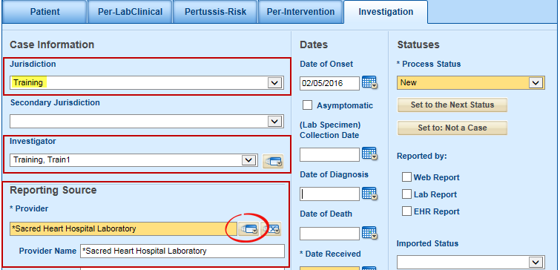

1. With the report source dictionary open, search for *Sacred Heart Hospital Laboratory as a provider, select it from the list of matching results, and click  at the bottom of the page.

*If you cannot find the report source, email* [*dhswedss@wisconsin.gov*](mailto:dhswedss@wisconsin.gov) *and ask us to set it up for you.*

1. Finally, add another note to the report and press

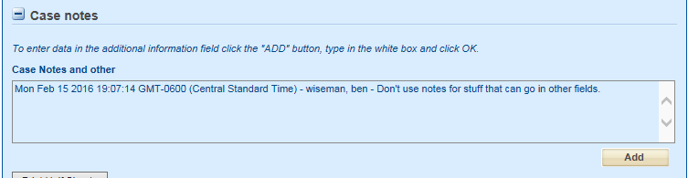

***Note****: There is an option to link this report to an outbreak, we don’t need to worry about that just yet. We’ll come to outbreaks later on.*

## Automatic Disregarding of Unknown Race

Purpose: Describe Race calculation behavior when a value other than ‘Unknown’ is selected without a pre-existing value of ‘Unknown’ being unchecked.

***Steps***

1. Select Patient B ##-Buffalo, Bill from My Case Load
2. Within the Patient tab locate the Race section (check boxes on right).

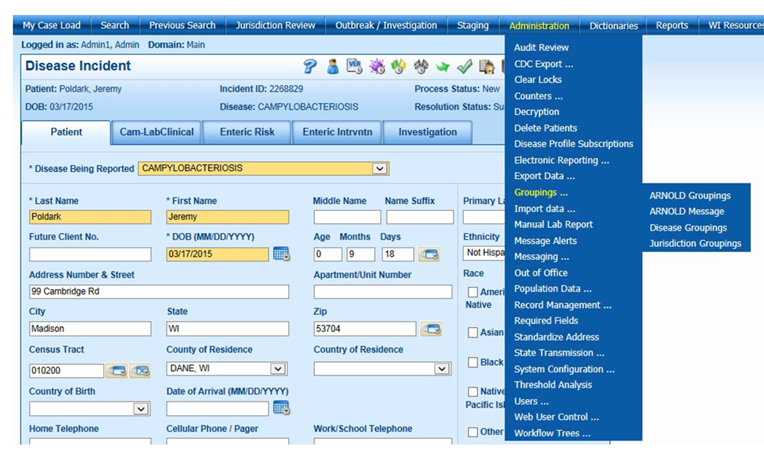

1. Check the Unknown box in the Race field.

Note “Reported Race” value was NOT updated to show “Multiple Race” by the selection of “Unknown.”

1. Now uncheck the Black or African American check box, with “Unknown” still selected.

Note “Reported Race” is now updated as “Unknown.”

1. Recheck the Black or African American check box, with “Unknown” still selected.

Note “Reported Race” is now updated as Black or African American.

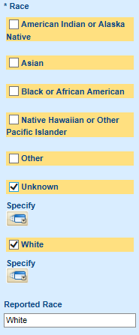

## Reported Race FAQs

1. When will a value of “Unknown” be used as the “Reported Race”?

*A value of “Unknown” will only be used if it is the only selection checked.*

1. If “Unknown” is selected along with another race, will WEDSS show “Multiple Race” in the “Reported Race” field?

*No, a value of “Unknown” will be overwritten by any other value that is chosen. The other race selected will be used in “Reported Race” field.*

*Previously, the WEDSS system updated the “Reported Race” field to ‘Multiple Race’ when ‘Unknown’ and another value were checked.*

1. Will any records that currently are set to Multiple Race due to one of the options selected being “Unknown” be updated in the new version of the system?

*No, any existing cases in the system will still have Unknown + [any other race category] display ‘Multiple Race.’ You can either update them on your own, or if you have a list, contact the WEDSS staff for an import template you can populate so we can correct the data for you.*

## Creating a contact investigation

A contact investigation is a handy way to report that a person was in contact with an infected individual and may be at risk of infection. Typically, one would add a contact investigation for sexually transmitted infections, vaccine preventable diseases, and perinatal Hepatitis B.

**Can you think of other situations where a contact investigation would be useful?**

**Let’s apply what you’ve learned above and create a new Pertussis contact investigation in the Training jurisdiction.**

1. Go back to the search screen. Type in Patient B’s name, and then click Contacts to find contacts associated with them.

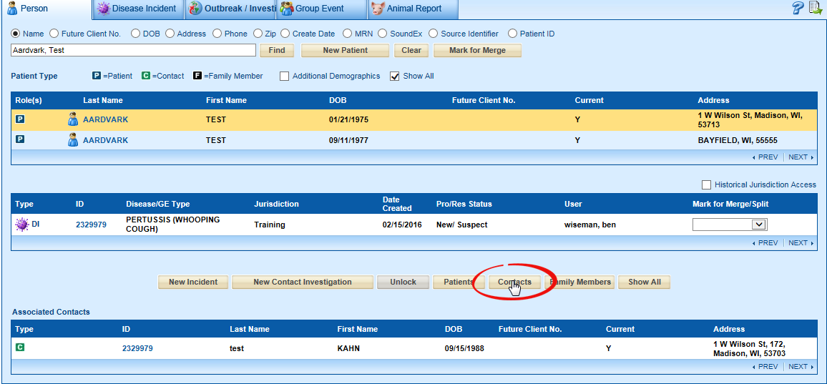

1. You should see the other patient you linked as a contact (Patient A) with a  to denote that they’re a contact. Click on the ID number in the Associated Contacts box. This will bring you back to Patient B’s Pertussis disease incident.
2. Go back to the Contacts section on the Per-intervention tab and click on the contact ID

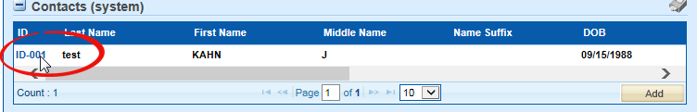

1. 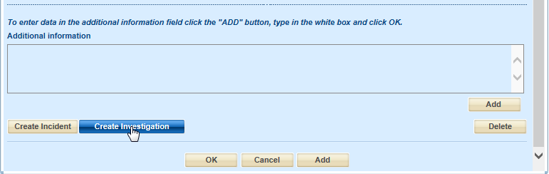This will open the contact data, click on Create Investigation near the bottom.
2. If asked whether you want to make a new version of the person, say no.
3. You will be told that a new contact investigation has been created. Click OK to exit the contact popup.

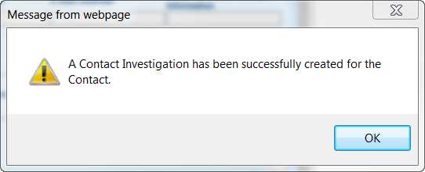

1. Go back to the search screen and find your Patient A. Can you see their new contact investigation?
2. From the search screen, open the contact investigation by clicking on the ID number

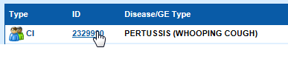

**Let’s say your contact falls ill, how might you make them into a disease incident? What options are available that might help with this?**

1. Go to the investigation tab and change the process status to Converted to Disease Incident and click Create Incident. Answer no when asked to create a new person version.
2. Go back to the search screen and look for Patient A—can you find their new pertussis disease incident?

## Animal Reports

Animal reports allow us to keep track of zoonotic diseases and their sources. While not everybody will use animal reports, it is still a good idea to understand how they work. Furthermore, there is some overlap between the procedure used in animal reporting and other areas of WEDSS.

We know that Patient B likes to report findings of dead birds to the Dead Bird Hotline. Let’s make an Animal Report for a West Nile Virus test.

1. Go to the search screen, and begin the process of creating a **new** animal report as you would for any other report type.
2. In the Animal Report form, feel free to create something imaginative, so long as you enter Patient B’s information as the Human to Contact and set the Jurisdiction to Training.

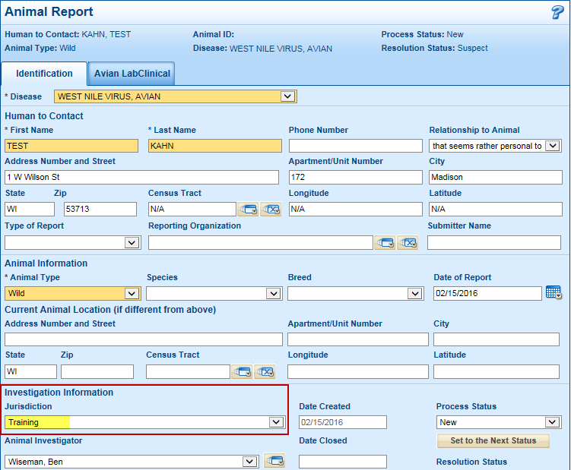

1. From the Avian LabClinical tab, experiment with filling out the different fields present, in particular, the ones that have the option to Add and Remove entries. Press  when you’re done.

**Don’t worry about entering anything specific; just get a feel for how the different data fields work.**

# Outbreaks

In this section, we will briefly go over **outbreaks**, in particular, how to **link** and **unlink** patients from these. We will be linking Patient A and B to a pertussis outbreak.

The technical qualifications for an outbreak vary by disease, so consult state staff if you have a question about whether a particular disease cluster would constitute an outbreak. For our purposes, we need only concern ourselves with being able to link outbreaks to reports and *vice versa*.

In this scenario, the pertussis cases in the Training jurisdiction have been classified as an outbreak.

1. To search for an outbreak, return to  and open the  Outbreak/ Investigation tab. There are several criteria that one can search by. Try to find the Salmonellosis outbreak that was created from the group event.

*Tip: Outbreaks should follow the naming convention of Year – Jurisdiction – Description.*

1. 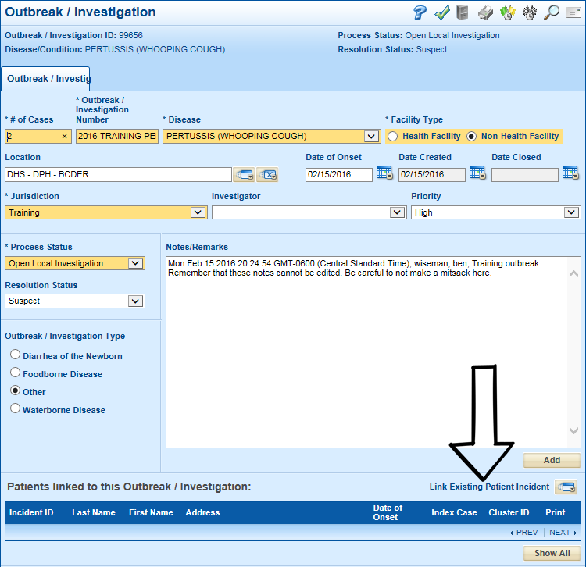Once you’ve found the outbreak, open it up and inspect it. **How would you link patients to it?**
2. **Go ahead and link your patients to it.**

*Do you see the following icons:* *******,* *******,* *******? What do you think they denote?*

1. **Return to the Person Search screen and look up your patient—can you find evidence of their being linked to an Outbreak Investigation?**

# Group events

Group events are public-health-related events that may or may not become relevant to cases of a notifiable disease to which persons can be linked. Examples of when a group event might be established include:

* Immunization clinics
* Potential environmental exposures
* Health education seminars
* Training sessions
* Health screening events

You can think of a Group Event as the equivalent of a Contact Investigation for an Outbreak.

Because Group Events are not commonly used in Wisconsin, we won’t cover how to create and link to group events in this training session. If you are interested, your quick reference guide contains an example of how to create a group event.

# Merging

**Patients**

Sometimes duplicated patient records are entered into the system, which causes duplicate records and duplicate work on the part of the nurse.

1. **Perform a person search** for your Patient B now; remember to enter the name as last, first.

You should see something like this:



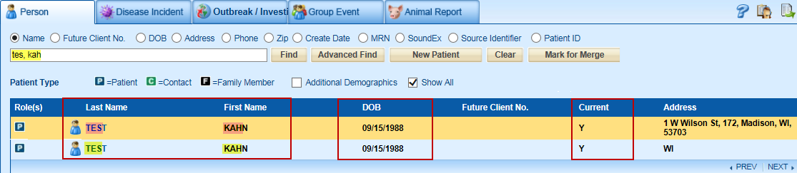

If we have a very good reason to suppose that these two patients are one in the same, we look to the Current column to tell whether or not a merge is necessary. Since both records have a Y in Current, we can tell that there are two copies of the same person in the system and **a merge is needed**. If only one of the matching people is current, there is no problem; the system is just showing previous versions of the same person. A couple examples of why a person might have multiple versions in the system include: if they have moved from one address to another, or changed their name due to marriage, divorce, etc.

Tip: before initiating the merge process, look at both people to see which person’s history you want to keep. Then mark the one you most want to keep for merge first, so its always marked as your Person 1.

1. Select each patient and click . When both have been marked for merge (their names will be red), you’ll see a popup saying both patients have been marked for merge.

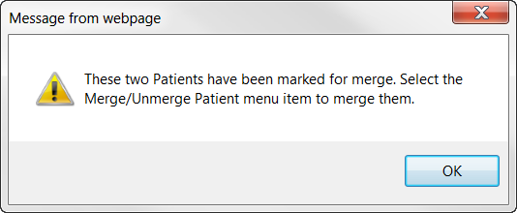

After the popup goes away, you may be wondering where to go next. If you don’t follow up with the merge process, your cases will sit in a queue waiting to be merged indefinitely.

1. Go to Administration > Record Management > Merge/Unmerge Patients

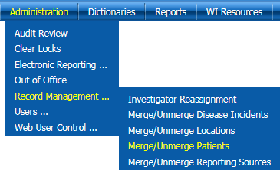

1. Search for your Patient B, select them, and click Continue or Select Details to proceed with the merge process.

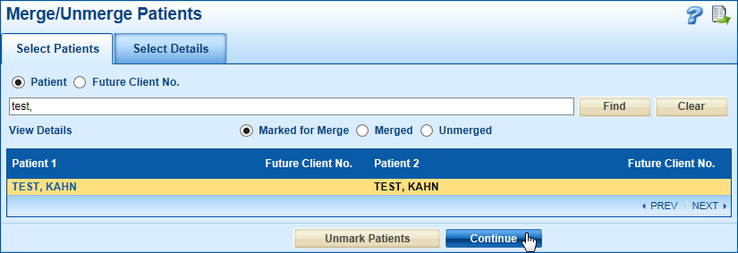

1. Select the most complete information from either patient that you want to be on the final version and select which Version History to keep and click Save when you’re finished.

The first patient marked for merge will be on the left, and the second on the right. In the center you’ll see the Final column displaying the data that will be held on the resulting record. At the bottom, you will see check boxes under the left and right columns saying Use This Patient’s Demographics—select one of these if you’re going to select all of either Patient 1’s or Patient 2’s Details (you can still change the individual selections afterward if you just want to cut corners when selecting most of a patient’s information.).

**There are also options for Keep Version History and Keep Both Patients’ Version History. When might we want to do this? Is the below screenshot correct in keeping both patients’ version histories? Could the  do something helpful here?**

The system can keep one or both version histories for the merged Patient. By default **the Keep Both Patients’ Version History** check box is checked. This **will save the address of both patients, listing the patient twice** with a “**Y**” **next to the current address**, designated by making the corresponding ‘Make Current Version/Keep Version History’ radio button, **and an “N” next to the other address** when a search by name is done.

Typically you would want to keep both when a person has lived at two different addresses and you want to keep that history. Uncheck this box to only keep the one patient version. Typically you would only want to keep one if the address history is an incomplete version of the second address version OR if both listings have the exact same address. If only one patient’s version is kept, the final version history is selected by making the corresponding ‘Make Current Version/Keep Version History’ radio button.

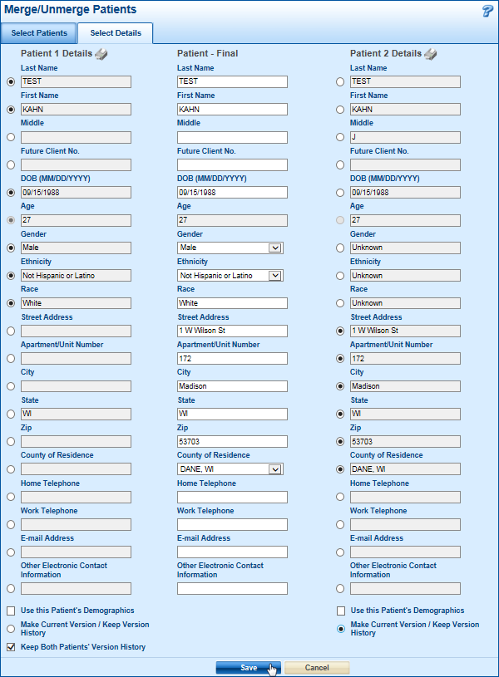If you need assistance with merging, or are unsure of what options to select, contact DHSWEDSS@dhs.wisconsin.gov

**Once you have merged a person, you should return to the search screen and search for the person. By merging people, you may now have duplicate disease incidents to merge**.

## Disease Incidents

Merging disease incidents follows largely the same process as merging patient records; the first noticeable difference is a minor change to how you mark incidents for merge. To mark a Disease incident for merging:

1. Search for and select the patient and look at their list of disease incidents. If you see matching incidents, navigate to the Mark for Merge/Split dropdown menu and set each to Mark for Merge.

**Tip**: Much like in the patient merge process, it is recommended that you review each incident individually to see what information from each incident you want to keep.

1. Select the one you want to keep the most information from and Mark for Merge first, so that it is always your Disease Incident 1. In addition, you may decide to copy information from the incident you are not keeping into the one you are keeping to make it easier once you are on the merge screens.

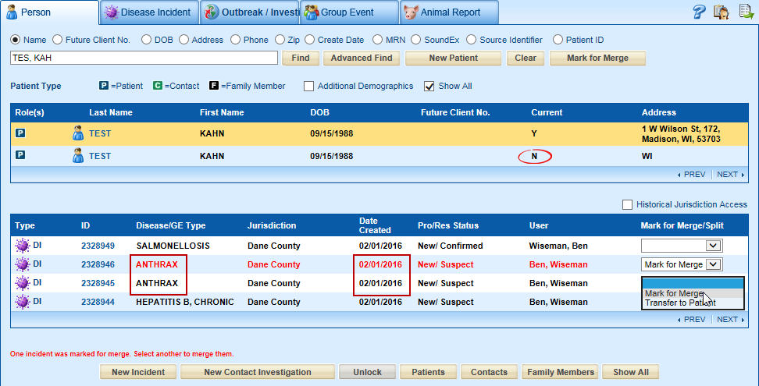

1. To get to the merge screen, you need to go to:

Administration> Record Management> Merge/Unmerge Disease Incidents

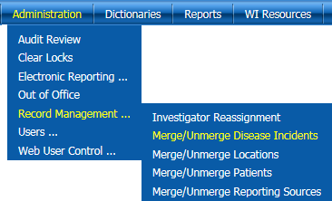

1. Search for the pair of incidents to merge by Patient B’s name. Select the pair of Disease incidents you wish to merge and press Continue or Select Details.

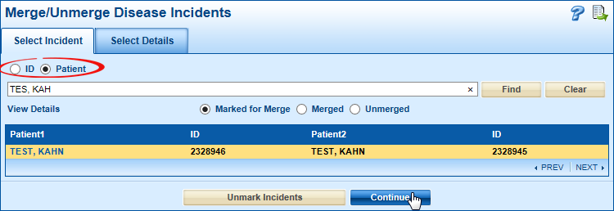

1. Select the most complete information in each tab from either disease incident to create the final, merged, incident. Specifically, you’ll want to take the tab with the most information. To compare disease-specific forms on each web report, click , which will pull up a window in which you can inspect both forms simultaneously. Empty sections are collapsed by default (*do you remember what these buttons  do?*). It is worth noting that you cannot edit the incidents while merging, you can only view their data.

To compare data from the Patient and Investigation tabs, click on the  icons beside Disease Incident Details.

For the sake of keeping the database tidy, it is best practice to select the lowest ID number. The same principle applies to the Date Created fields.

“Keep this Incident’s History” keeps the following from the incident selected:

* Audit
* Condition History
* Jurisdiction History
* Link to Animal Report
* Medical Record Numbers
* Process Status History
* Record Level Alerts
* Resolution Status History
* Task Lists and associated data
* User-defined sections on the Demographics and Investigation tabs
* Version History
* Notes

Press  when you’re finished.

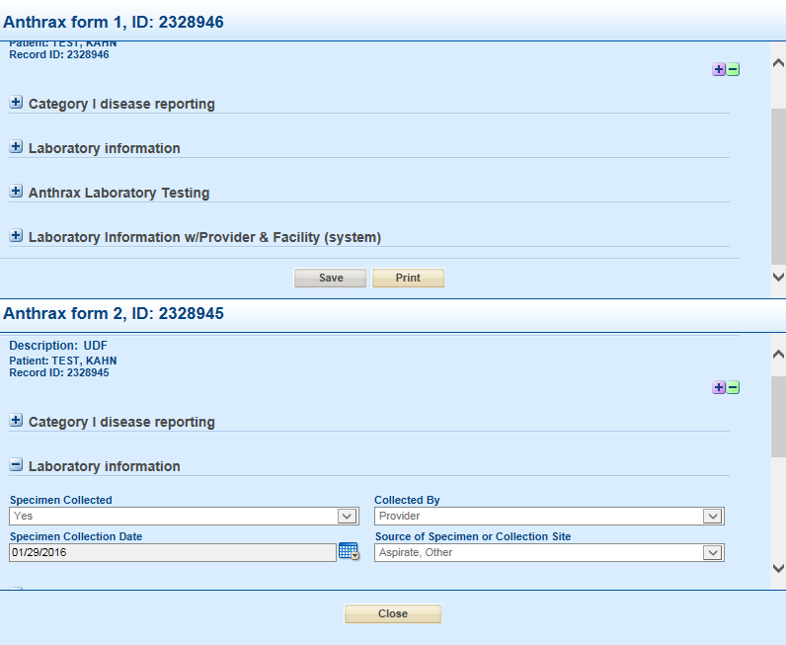**What would you do if the information held on the different tabs possessed completely different, yet valid, information in different fields on the same tab? Can you think of a way to avoid throwing away useful data?**

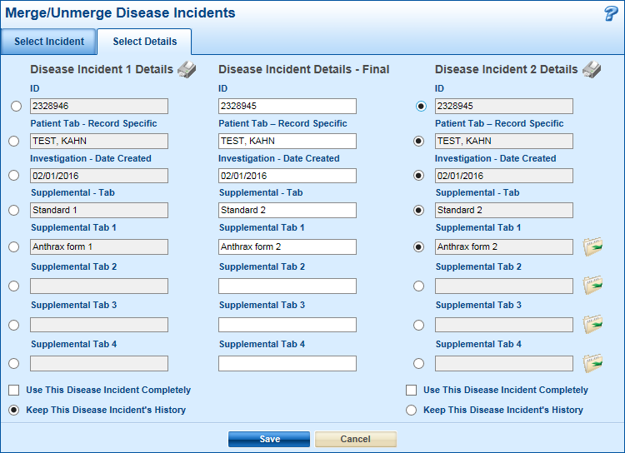

***Note****: There is an in depth guide to merging for your reference on our Sharepoint site and on the USB drive you received.*

# Hospitalization Information

WEDSS will now display hospitalization information, including whether the patient was an inpatient or outpatient and the admission and discharge dates.

***Steps***

1. Click on Search in the top navigation menu.
2. Enter the first three letters of the last name, then the first three letters of the first name. PET, PAU (and locate Pertussis Case for “Peters, Paula”). Then select Find.
3. Select the ID to view the record.
4. Click on the Filing Cabinet Icon. 

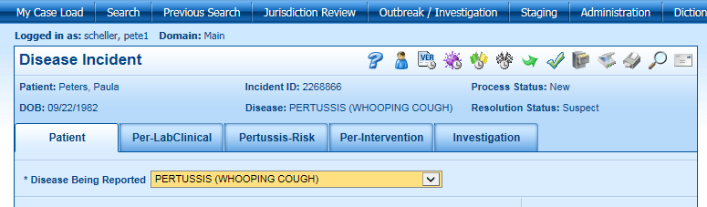

1. From within the filing cabinet, click on a Web Report to view or print.

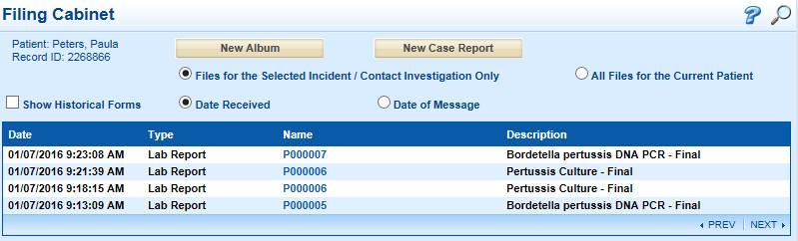

1. Note Patient Class: I = Inpatient, O = Outpatient and admit and discharge dates.

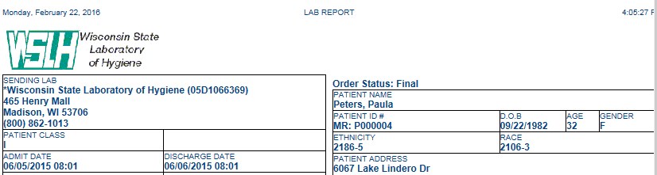

7. Select the investigation tab to view basic hospitalization information.

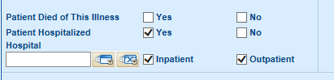

## Hospitalization Information FAQs

1. What details will I see if a lab sends information that a person is an outpatient and when will those details appear?

*If a lab sends information that the person in an outpatient, you will see an “O” and no information about dates.*

*Upon import, not hospitalized will be checked, outpatient will be checked, dates will not be filled in. However, if the patient was previously hospitalized, “hospitalized” will overrule “not hospitalized” and remain checked with “not hospitalized” remaining unchecked.*

***Note****: existing data (including admit date, discharge date, inpatient checkbox and outpatient checkbox) will not be overwritten.*

1. What details will I see if a lab sends information that a person is an inpatient and when will those details appear?

*If a lab sends information that the person is an inpatient, you will see an “I” and the admission and discharge dates if they are provided.*

*Upon import, “hospitalized” will be checked, inpatient will be checked, and dates will be filled in. If “not hospitalized” is already checked due to a previous outpatient visit, “hospitalized” will be checked and “not hospitalized” will be unchecked.*

***Note****: existing data (including admit date, discharge date, inpatient checkbox, and outpatient checkbox) will not be overwritten.*

1. If a lab report is reversed back to staging, will hospitalization information be deleted?

*No, if the lab report is reversed back to staging, hospitalization information will NOT be deleted.*

# The staging area

## An overview of staging

The staging area is a key part of WEDSS, it is the interface between incoming reports from laboratories, providers, and the live surveillance database. Mistakes here can cause problems downstream.

The staging area is a holding area for incoming records submitted by labs and providers. You will become well acquainted with the staging area if you are not already. You may also refer to the annotated user interface below. The essential steps of staging that we are going to cover are:

* Filtering the staging area
* Finding matching records
* Identifying current and non-current records
* Selecting the correct import option
* Managing the incoming patient information correctly
* 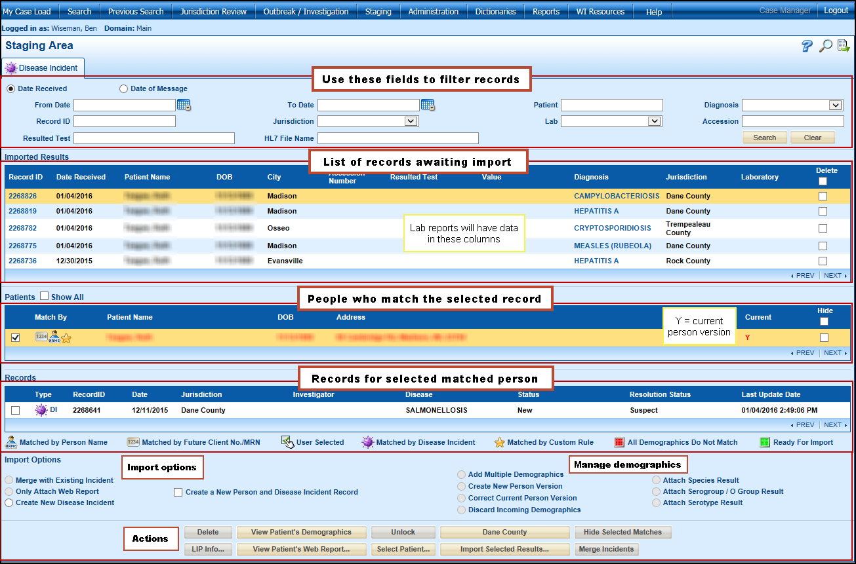Importing records correctly

### Finding records and checking that they’re current

When you select a record from the Imported Results, the system will attempt to search for matching people in the system. The automatic search is not perfect, so one should click the  button if there are no matches found.

Within the Select Patient search, you can conduct a wider search of last name, first name convention similar to the Search Screen, or DOB, or combination of DOB and first three letters of the last name, first three letters of the first name. If you find a match, highlight the match and click OK. The selected person will now show up in the matched area for selection.

If and when you see a matching person, you can tell whether they’re current or not by a Y in the Current column. When it comes to attaching and merging results, this is important to know.

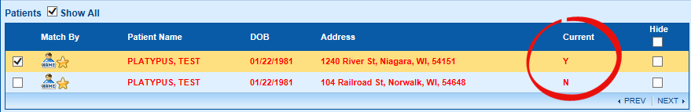

### Comparing patients’ demographics

To compare the demographics of selected patients, press , which will pull up the Demographics window to allow a side-by-side comparison of the selected person versions.

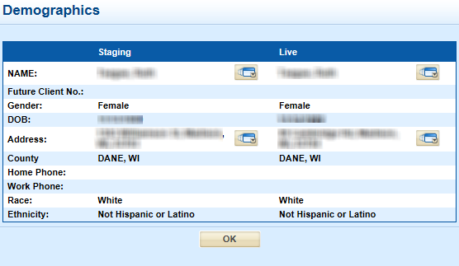

## Basic Workflow

1. Select a record from the list of Imported Results
2. Select their previous entry in the system (if one exists) from the Patients’ list.
3. If you are unable to see any matching records for the patient, click 
4. If there is a matching patient, look at the list of Records. If a record for the same disease incident exists, select it.
5. If you have selected a matching person, click  to check for any differences in the demographics of the staged, and live record.
6. Check whether the report is a web or lab report. A lab report will have values for Accession Number, Resulted Test, Value, and Laboratory in the middle (results) columns. In addition, in the action button area, you will see “View Patient’s Lab Report” or “View Patient’s Web Report” depending on the type of report it is.
7. If the staged record is a web report, select the import options to merge it with the existing report or to create a new person and/or disease incident as appropriate.

Otherwise, if the staged record is a lab report, select the import options to attach it to the existing report or to create a new person and/or disease incident as appropriate.

## Never attach a web report!

When we attach a record, **we** are effectively saving an image of it to the filing cabinet. Consequently, **if a web report is attached, all of the data within it becomes inaccessible**. Furthermore, if provider appends anything to the record’s Electronic Filing Cabinet after it is submitted and a **local health department attaches a web report, the data within the filing cabinet will become hidden from the local health department**. We would disable the option if we could.

## Updated Demographic Import Options

The Staging Area in WEDSS differs significantly between versions 14 and 15 with regard to managing incoming demographics. The changes were made to make the process of changing and discarding demographics more intuitive.

For example, in CMR14, not selecting Update Demographics will not discard the incoming demographics; rather it will save the incoming demographics as secondary. Furthermore, as there are several ways in which one could seek to update a patient’s information, having a single option is vague.

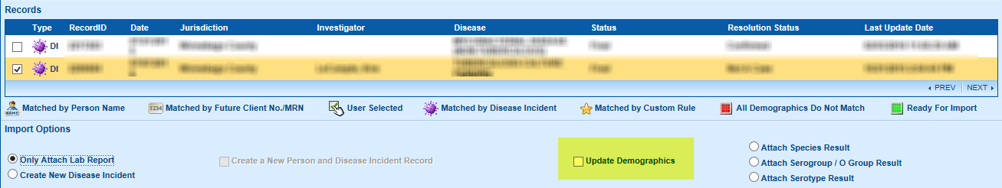

In CMR15, there are four options for managing incoming demographics: Add Multiple Demographics (the current behavior when Update Demographics is not selected), Create New Person Version (current behavior when Update Demographics is selected), Correct Current Person Version, and Discard Incoming Demographics.

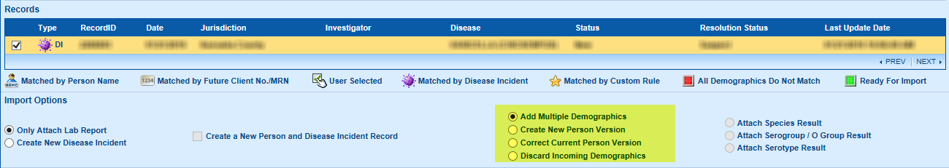

Next we will cover when and why you should use each new import option. Additionally, consult your quick reference handout, which contains flow diagrams that you may find helpful. Should you get stuck, or if you are unsure about something, please contact the WEDSS team at [DHSWEDSS@wisconsin.gov](mailto:DHSWEDSS@wisconsin.gov) for assistance.

**Discard**

This is the most intuitive of the demographic import options; by selecting Discard Demographics, we are telling the system to only associate the incoming record with the selected patient and disease incident (if applicable), without affecting any demographic information stored in the system. Typically, you would use this for new disease incidents for existing patients whose demographics (address, contact information, etc.) have not changed since their last disease incident or when there are multiple incoming lab results for the same disease incident.

*Can you think of some pros and cons for discarding the incoming information rather than simply adding it as secondary?*

**Correct current person version**

When the live record has a paucity of data or it contains a mistake, we can use Correct Current Person Version to augment and adjust the demographic information of the current person version.

*What do you think would happen if you applied this option to a non-current person version? When might such a situation arise?*

**Create new person version**

When a patient has moved, the system needs to be told that their old address is not current. Create New Person Version will make the current version of the selected person become secondary (old) and the demographics of the incoming report will be used to create a new current person version.

*When might we want to make the incoming demographics a new person version?*

**Add multiple demographics**

This was the default behavior of not selecting Update Demographics in CMR14. Adding multiple demographics will not affect the patient’s primary information (what you would see on the patient tab in a report), it will simply add staged demographics as secondary details. It may seem strange to have multiple addresses on a person; however, in cases where the disease incident must stay in its original jurisdiction, like Hepatitis C, or the patient has multiple simultaneous addresses, such as a child who spends time between the addresses of separated parents, adding multiple demographics is needed.

*Why is this currently the default behavior when Update Demographics is not selected?*

**What are your initial thoughts about this update? Do you think it will be useful to you?**

### Practical exercises

In the staging area, you may see people associated with your patients. We will work on the topmost patient as well as a specific Date of message.

1. **Attaching a lab to a chronic disease**.
   1. Find your staged records with a Date of message of 09/04/2015 and look for your Patient A.
   2. Select Patient A’s Hepatitis C record. Was a match found? If not, click on .
   3. Determine whether this report is a web or lab report? Can you see data in lab fields?
   4. Select the patient match for Patient A by ticking the checkbox by their name.

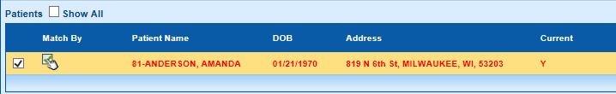

Remember, your Patient A will have your number before their last name.

* 1. Select the matching Hepatitis C record below. 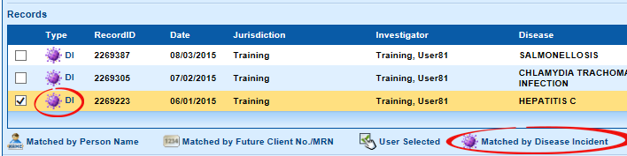
  2. Select Only Attach Lab Report . What color is the staged record now?
  3. Refer to the flow chart in your handout. Can you think of why it tells you to select Add Multiple Demographics for this record?
  4. Select Add Multiple Demographics and click on .

1. **Creating a New Disease Incident**
   1. Find staged Chlamydia Trachomatis Infection records for your Patient A.
   2. Select Patient A’s Chlamydia Trachomatis Infection **web** report. Was a match found? If not, press .
   3. Double check that you have selected the web report and not the lab report. Wherever possible, a web report should be imported before a lab report.
   4. Select the current person version for Patient A by ticking the checkbox by their name.
   5. Because this is not a chronic disease, we need to carefully check if the current person version needs to be changed. Press  and inspect the demographics of the live (current person version) and the staged record.

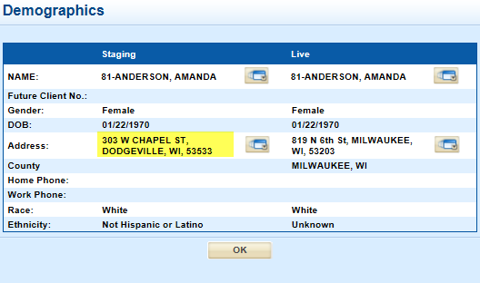

* 1. Are there any existing records for this disease incident? **Remember to look at the time of an incident when deciding whether or not it matches.**
  2. Refer to your flow chart—what import options do you think are correct here?

*Answer: Because this is a new disease incident on an existing person who has moved since last time, select  and* *******.*

1. **Attaching a lab**
   1. Find your staged records with a Date of message of 09/24/2015 and look for your Patient A.
   2. Select Patient A’s Chlamydia Trachomatis Infection **lab** report. Was a match found? If not, press .
   3. Select the current person version for Patient A by ticking the checkbox by their name. **How can you tell which version is current?**
   4. Check if the current person version needs to be changed. Press  and inspect the demographics of the live (current person version) and the staged record. You should find that they match.
   5. Select the Chlamydia record you just imported by ticking the checkbox beside it.

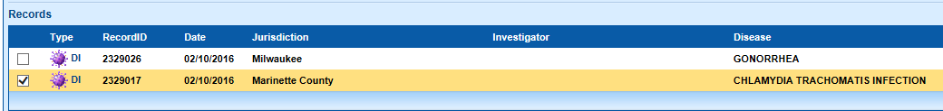

For the sake of this exercise, let’s pretend that the record is current.

* 1. A matching record exists and the staged record contains no new demographic information. Refer to your flow chart – what import options do you think are correct here?

*Answer: Because this a new report for an existing disease incident on an existing person, who has not moved since last time, and the staged record does not contain any new or improved demographic information, select Only Attach Lab Report and Discard Incoming Demographics.*

1. **Attaching a lab 2**
   1. Find your staged records with a Date of message of 12/09/2015 and look for your Patient D.
   2. Select Patient D’s Gonorrhea **lab** report. Was a match found? If not, press .
   3. If you don’t find them right away, use the searching techniques we learned earlier.
   4. Select the current person version for Patient D by ticking the checkbox by their name.

We need to carefully check if the current person version needs to be changed. Press  and inspect the demographics of the live (current person version) and the staged record.

* 1. **Do you see any information that is better in the staged record than in the live record?**
  2. We want to fix Patient D’s information with data in the staged report, and they do not currently have a Gonorrhea incident. What option can we use here?

Circle the correct option and then carry out the operation when you are sure you are correct.

*Answer: Because this a new report for a new disease incident on an existing person whose information on file is erroneous, we could select Create New Disease Incident and Correct Current Person Version.*

*Note that in practice, given the extent of the data entry errors, we would also call the patient’s provider to verify their information and manually correct if needed.*

1. **Merging a web report**
   1. Find your staged Hepatitis C records from any date and look for your Patient B.
   2. Select Patient B’s Hepatitis C **web** report. Was a match found? If not, press .
   3. Select the current person version for Patient B by ticking the checkbox by the name of the current person version.
   4. Check if the current person version needs to be changed. Press  and inspect the demographics of the live (current person version) and the staged record.
   5. **Are demographics the same**?
   6. Refer to your flow chart—what import options do you think are correct here.

*Answer: Because this is a chronic disease on an existing person who has moved since last time, select Merge With Existing Incident and Add Multiple Demographics.*

* 1. You should then click .
  2. You will then receive the following prompt.

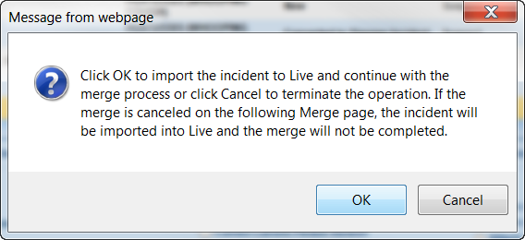

* 1. Proceed with the merge as discussed before.

1. **Create a New Person and Disease Incident Record**
   1. Find staged records for your Patient C.
   2. Select Patient C’s Gonorrhea **lab** report. Was a match found? If not, click on .
   3. Check again that they don’t exist in the system using what you have learned earlier.
   4. If you are sure they do not exist in the system, check  and then .
2. **Creating a New Disease Incident 2**
   1. Find your staged records with a Date of message of 10/06/2015 and look for your Patient A.
   2. Select Patient A’s Influenza Associated Hospitalization **lab** report. Was a match found? If not, click on .
   3. Select the current person version for Patient A by ticking the checkbox by their name.
   4. Check if the current person version needs to be changed. Click on  and inspect the demographics of the live (current person version) and the staged record.
   5. Are there any existing records for this disease incident?
   6. Refer to your flow chart—what import options do you think are correct here?

*Answer: because this is a new disease incident on an existing person who has not moved since last time, select Create New Disease Incident and Discard Incoming Demographics*

1. **Creating a New Disease Incident 3**
   1. Find your staged records with a specimen date of 10/17/2015 and look for your Patient B.
   2. Select Patient B’s Chlamydia Trachomatis **lab** report. Was a match found? If not, press .
   3. Select the current person version for Patient B by ticking the checkbox by the name of the current person version.
   4. Check if the current person version needs to be changed. Click on  and inspect the demographics of the live (current person version) and the staged record.
   5. Are there any existing records for this disease incident?
   6. Refer to your flow chart – what import options do you think are correct here?

*Answer: Because this is a new disease incident on an existing person who has moved since last time, select Create New Disease Incident and Create New Person Version.*

1. **Attaching a lab 3**
   1. Find your staged records with a Date of message of 10/27/2015 and look for your Patient B.
   2. Select Patient B’s Chlamydia Trachomatis **lab** report. Was a match found? If not, press .
   3. Select the current person version for Patient B by ticking the checkbox by the name of the current person version.
   4. Check if the current person version needs to be changed. Click on  and inspect the demographics of the live (current person version) and the staged record.
   5. **Are demographics the same**?
   6. Your patient has moved since last time they were tested, but the disease incident is still current. Refer to your flow chart—what import options do you think are correct here?

*Answer: Because this is* ***not*** *a new disease incident on an existing person and the staged record has more complete information, select Only Attach Lab Report and Correct Current Person Version*

1. **Attaching a lab 4**
2. Find your staged records with a Date of message of 10/27/2015 and look for your Patient B.
3. Select Patient B’s Chlamydia Trachomatis **lab** report. Was a match found? If not, click .
4. Select the current person version for Patient B by ticking the checkbox by the name of the current person version.
5. Check if the current person version needs to be changed. Click on  and inspect the demographics of the live (current person version) and the staged record.
6. **Are demographics the same**?
7. Your patient has not moved since last time they were tested, and the disease incident is still current. Refer to your flow chart—what import options do you think are correct here?

*Answer: Because this a new report for an existing disease incident on an existing person who has not moved since last time and the staged record does not contain any new or improved demographic information, select Only Attach Lab Report and Discard Incoming Demographics.*