Advanced End User: WEDSS Reports and AVR
For WEDSS version 15, revised July 20, 2016

Contents
Reports in WEDSS 3
Cumulative Report 3
Generating a Cumulative Report 3
De-Identified Reports 5
Generating a De-Identified Report 5
Epi Curve 8
Generating a Epi Curve 8
Ranged Reports 9
Types of Ranged Reports 9
Generating a Ranged Report 10
Templates 12
Real Time Graphs 12
Generating a Real Time Graph 12
Analysis, Visualization, and Reporting (AVR) 14
Reports in AVR 14
Creating New Reports 18
Using Templates 18
Using the Report Wizard 22
Creating Reports without the Report Wizard 18
Editing Reports 26
Viewing Reports 28
Saving Reports 30
Exporting Reports 31

Reports in WEDSS

Cumulative Report
This report type provides the number of Disease Incidents by disease name and the number of Outbreaks by ‘Outbreak Type’ (i.e. Diarrhea of the Newborn, Foodborne Disease, Other, and Waterborne Disease).

Generating a Cumulative Report
To access the ‘Cumulative Report,’ navigate to the ‘Reports’ menu and then select ‘Cumulative Report.’
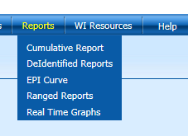
You will receive a pop-up window that will prompt you to select your filtering criteria.
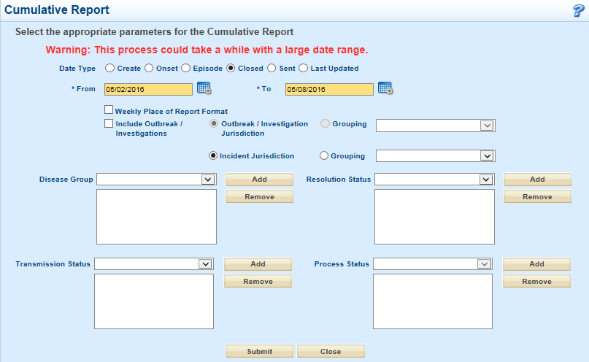
First, select the ‘Date Type’ to use. Select the data for your report between a date range by entering ‘To’ and ‘From’ dates. If you select the ‘Weekly Place of Report Format’ checkbox, the report will use the designated ‘Week Number,’ based on the date entered in the ‘From’ date field.

To include a count of the number of Outbreaks, select the ‘Include Outbreak/Investigations’ checkbox. This option is not recommended because the grouping is not informative (you cannot group by the disease of the particular outbreak).
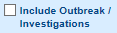

To filter the report by Jurisdiction (labelled ‘Incident Jurisdiction’) or Jurisdiction Group (labelled ‘Grouping’), select the radio button and open the drop-down list.
You can further filter by ‘Resolution Status,’ ‘Process Status,’ and ‘Transmission Status.’ To apply multiple filters for each report, click the ‘Add’ buttons.
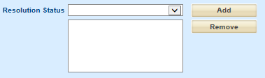
To filter by multiple Disease Groups,’ select the Grouping radio button, open the drop-down list, and select ‘Disease Groups’. However, this selection will separate each group into separate sections of the report. This will limit your ability to easily review each ‘Disease Group’ by the disease count total.
To generate the report, click the ‘Submit’ button and a new tab will open in your browser based upon your selected disease incident criteria.
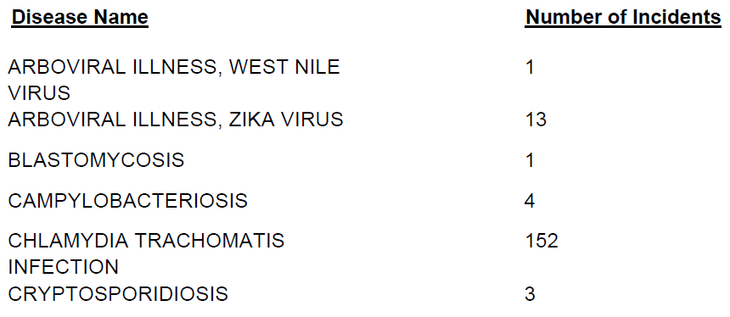

De-Identified Reports
This report type generates an Excel pivot table of the corresponding data generated from your selections. Once in Excel, additional data fields can be selected and added to the pivot table.

Generating a De-Identified Report
To access the ‘De-Identified Reports,’ navigate to the ‘Reports’ menu and select ‘De-Identified Reports.’
Upon selecting the ‘De-Identified Reports’ option, the ‘Disease Counts and Incidence Rates – Pivot Table Generator’ screen will appear and will prompt you to set parameters for your report.
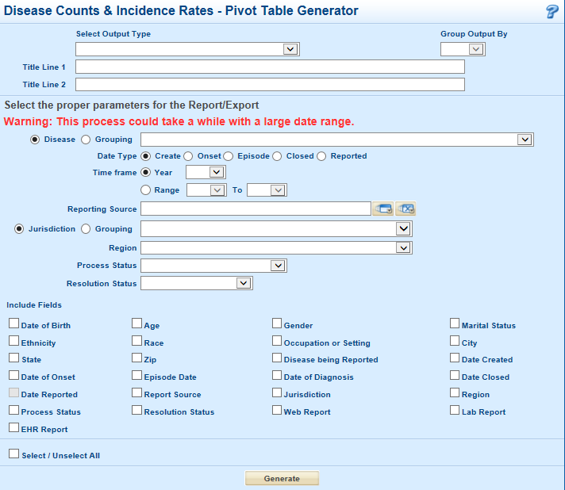
The first four options determine the format of your pivot table output.
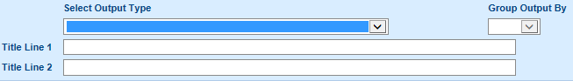
To select pre-created columns in your pivot table, use the ‘Select Output Type’ section to enter the following:
- Number of Cases
  - One column for number of cases.
- Number of Cases by Jurisdiction
  - Multiple columns, one for each Jurisdiction available.
- Number of Cases by Jurisdiction and Process Status
  - Multiple columns, with Jurisdictions as subgroups for each Process Status.
- Number of Cases by Jurisdiction and Resolution Status
  - Multiple columns, with Jurisdictions as subgroups for each Resolution Status.
NOTE: You can NOT export data related to incidence rates. If you need to create rate based data reports, use Analysis, Visualization, and Reporting (AVR) instead.
To add columns to indicate the month, week, or day (of the month), select the desired option under the ‘Group Output By’ drop down list.
Based on the selections of ‘Select Output Type’ and ‘Group Output By,’ the ‘Title Lines’ will populate with information. That information will appear on the report in a pre-designated format as a Title. You can edit this information or you can choose to wait and edit the final report.
The next set of fields allows you to filter what cases will be displayed in your report.
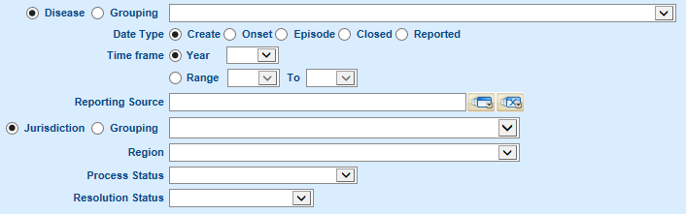
It is highly recommended that you use the filter and capture only the information you need, rather than exporting all of the available WEDDS data. Filtering will allow you to quickly generate a report in a more useful format.
The final section under ‘Include Fields’ as seen below allows you to select additional information to be included in the final report. The additional selected items will not appear in the pivot table first generated; however, the fields may be used to edit the pivot table after it has been generated or it may be used to create additional pivot tables on your own.
NOTE: Disease Incident ID numbers are not available in this report.
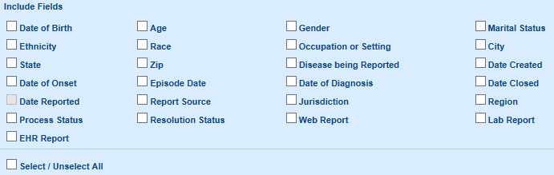
Once you have selected all of the data fields that you need, click the ‘Generate’ button. After processing, an Excel document will be generated with your designated pivot table.
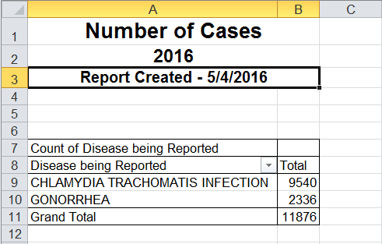
You are now ready to edit the information in your pivot table and to add fields to specify case counts. Click on the pivot table you just generated to begin editing. 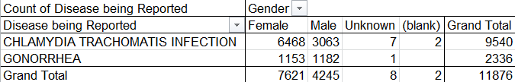
Access the data that is available to be displayed in the pivot table by clicking on the ‘Data’ tab.

Epi Curve
This report type generates a line graph of confirmed cases by week for a given ‘Create Year,’ with a baseline calculated from previous years’ data for comparison.

Generating a Epi Curve
Access the ‘Epi Curve’ by navigating to the ‘Reports’ menu and select ‘Epi Curve.’
The ‘Epi Curve’ screen allows you to select the ‘Create Year’ for the Disease Incidents that you want graphed. The ‘Epi Curve’ screen also allows you to define the number of years you would like to include in a baseline calculation, which is based on the average number of cases reported during that time frame.
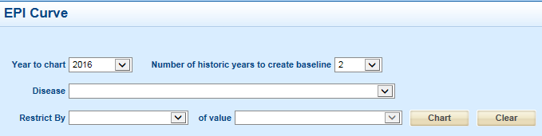
You are also able to filter the cases being displayed by Disease, Jurisdiction, Jurisdiction Group, Region, Zip Code, and Disease Incidents that you as a WEDSS user created.
When you have selected your criteria, click the ‘Chart’ button and the graph will be generated.
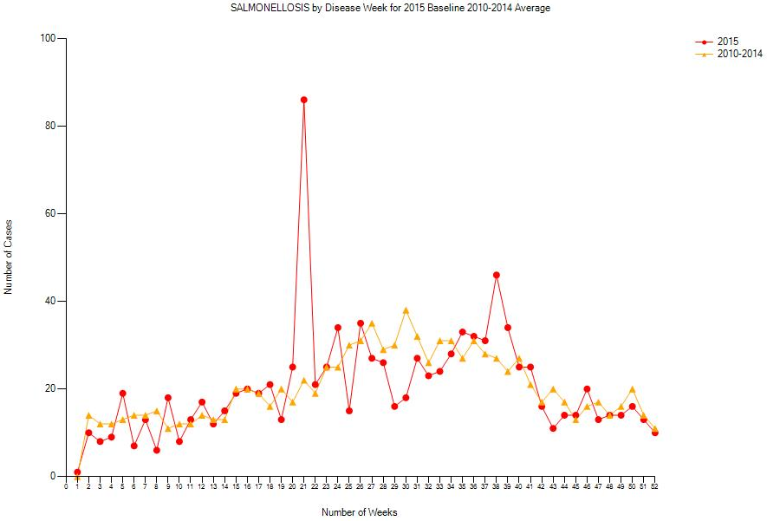

Ranged Reports
This report type allows for exports of data contained within an area of a form or for a particular record type within the system. Additional details about each ranged report type are outlined below.

Types of Ranged Reports
- Animal Report Export
  - Allows for the export of Animal Report data that is related to the information on the Identification tab.
- Case Report Export
  - Allows for the export of data that has been entered into a disease-specific tab or case report. There are options to include the relevant System Sections and the ‘Core Data’ on the relevant System Tabs (e.g. Patient or Investigation tabs).
  - This report always exports to the Microsoft Access format.
- Cumulative Disease Report
  - Generates a report with identifiable case level data in a preset format.
- Image Export
  - Allows for the export of all images that are uploaded into the ‘Filing Cabinet.’
- Incident and Investigation Export
  - Allows for the export of Disease Incident and Contact Investigation data that’s related to the information on the Patient tab, Investigation tab, and the System Sections (i.e. Lab, Contact, and Exposure Event widgets).
- Outbreak/Group Event Export
  - Allows for the export of Outbreak or Group Event data that’s related to the information on the Outbreak/Investigation or Group Event tab and the System Sections (i.e. Contact and Exposure Event widgets).
- Outbreak by Disease Report
  - Generates a report with summary information related to outbreaks in a preset format.
- RVCT exports
  - Exports data that has been entered on the selected RVCT tabs.

Generating a Ranged Report
You can access ‘Ranged Reports’ by navigating to the ‘Reports’ menu and selecting ‘Ranged Reports.’
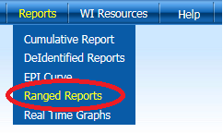
Upon, selecting the ‘Ranged Reports’ menu item, you will be prompted to select the type of Report or Export you wish to run on the ‘Ranged Reports’ page
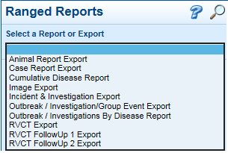
The options for the ‘Select a Report or Export’ will determine the available filtering criteria for your report. To ensure a successful export, select the appropriate parameters to return the data you need. Large date ranges (i.e. multiple years) may take a long time to complete. To generate a report that requires large date ranges, it is recommended that you use AVR or SSRS.
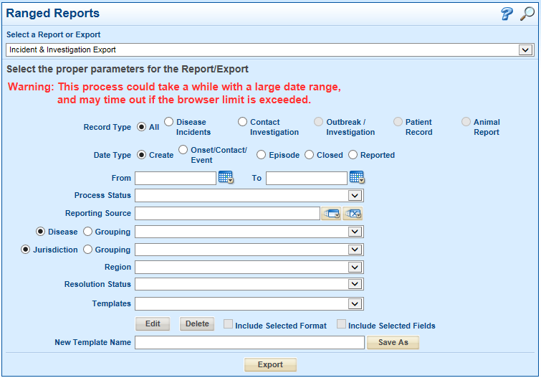
Once you have selected filters for your report, click the ‘Export’ button. A pop up window will appear, prompting you to select the file format of the generated report and the fields that will be displayed (i.e. Export Type). The fields available for your selection depend on the report type selected. Once you have made your selections, click the ‘Export’ button. 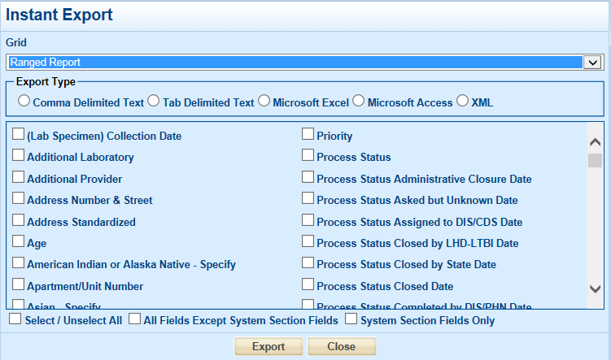
Note: Any report that contains System Sections, or the Case Report Export, will only export to Microsoft Access.

Templates
To keep the same filtered criteria for future reports, save a Ranged Report as a ‘Template.’ To save an initial template, set your filter criteria and type a descriptive and informative name in the ‘New Template Name.’ To keep the same selected fields and export format saved in your template, check the ‘Include Selected Format’ and/or ‘Include Selected Fields’ check boxes prior to clicking the ‘Save As’ button.
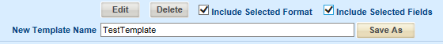
To edit an existing template, select the desired template from the ‘Templates’ drop-down menu and click the ‘Edit’ button.
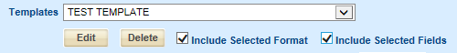
When you are done making your changes to available filters, click the ‘Save’ button that was previously the ‘Edit’ button.
Note: If you want to make changes to the selected fields or export format, be sure to un-select the two ‘include’ checkboxes, click the ‘Save’ button, and then re-edit the template, selecting the two ‘include’ checkboxes again, before saving a second time. This will then prompt you to select the fields when you generate the report.

Real Time Graphs
This report type generates a column chart of the number of cases broken down by Month (of Date Type), Year (of Date Type), Age Group, or Race Group.

Generating a Real Time Graph
To access the ‘Real Time Graph,’ navigate to the ‘Reports’ menu and select ‘Real Time Graph.’
Upon selecting the ’Real Time Graph,’ you will be taken to the ‘Real Time Graph Setup’ page to select the parameters of the graph that will be created
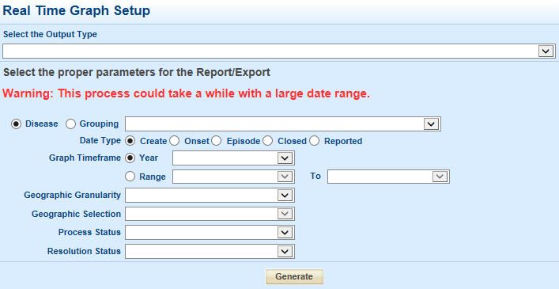
‘Select the Output Type’ drop down option to determine the categories displayed in your column chart. The categories include:
- Number of Cases by Month (of Date Type)
- Number of Case by Year (of Date Type)
- Number of Cases by Race/Ethnicity (AVR is recommended to access these fields instead)
  - Groups are: African American-Black, American Indian-Alaskan Native, Asian-Pacific Islander, Multiple Race, Other, Unknown, and White.
- Number of Cases by Age Group
  - Groups are: Infants (0), Toddler (1-2), Preschooler (3-5), Children (6-8), Youth (9-11), Early Adolescence (12-15), Late Adolescence (16-18), Young Adults (19-24), Adult (25-44), Middle Age Adult (45-64), and Elderly (65-120).
NOTE: You can NOT export data related to incidence rates. To create rate based data reports, use AVR.
To filter the data being displayed by Disease, Date, Geographic area (county, jurisdiction, or region), Process Status, and Resolution Status, select your filtering criteria and click the ‘Generate’ button.
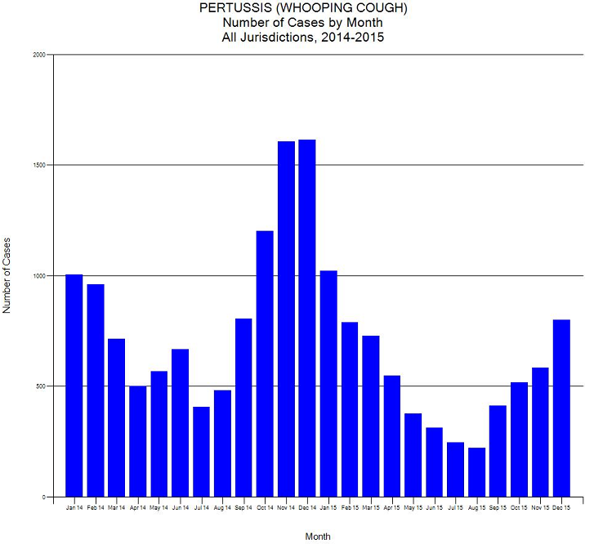

Analysis, Visualization, and Reporting (AVR)
AVR is accessed at the following website: https://avr.wisconsin.gov.
The login information for the site is your WAMS account information.
If you need access to AVR, contact DHSWEDSS@wi.gov.

Reports in AVR
There are a number of existing reports that may be helpful to you. In addition, you can make edits to these reports (e.g. filter by jurisdiction or custom date ranges), and save the edited versions in personal folders for future use.
Reports accessed on the WEDSS tab:
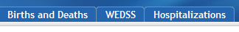
- WEDSS Report - contains five sub reports.
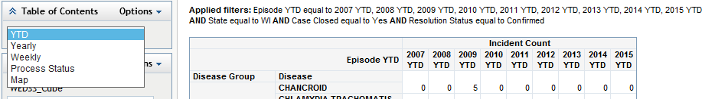
  - YTD – Provides Year-To-Date case counts for Confirmed, Closed, and WI cases by disease. For historical years, the YTD count is the number of cases from January 1st – today’s date in that year.
  - Yearly – Provides Yearly case counts for Confirmed, Closed, and WI cases by disease. For historical years, it will include the full calendar year.
  - Weekly – Provides a table and chart of weekly cases counts for WI cases for the past 52 weeks.
  - Process Status – Providers case counts for all WI cases by disease and their assigned Process Status.
  - Map – Provides a map and table of Confirmed, WI case counts by county.
- WEDSS QA Data – Provides general de-identified information about all Disease Incidents in WEDSS (e.g. ID number, relevant dates, Process Status, Resolution Status).
- WEDSS Incident Creation Report – Provides a chart and table of how Disease Incidents were created in various years.
- Avian West Nile Virus-Bird Report – Provides a count of reported birds, by type and year, and if they were collected, tested, and result of testing.
- Avian West Nile Virus-Line List – Provides a list of reported birds and their location.
QA Reports accessed in the ‘Web Report Studio’ on the Home tab:
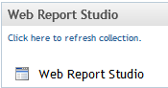
Click on ‘Web Report Studio’ on the Home tab, and this will bring you to the ‘Getting Started’ page. To browse for existing reports, click on either the ‘Open’ link or the ‘More Reports…’ link.
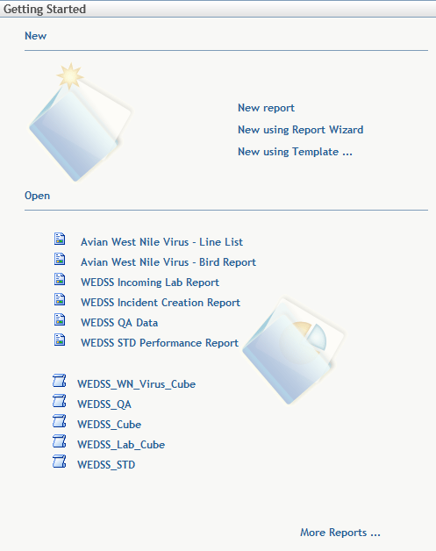
There are many existing reports available that have been created for many different public health prevention and control purposes. The ‘QA’ reports all start with the title ‘Routine QA Reports.’
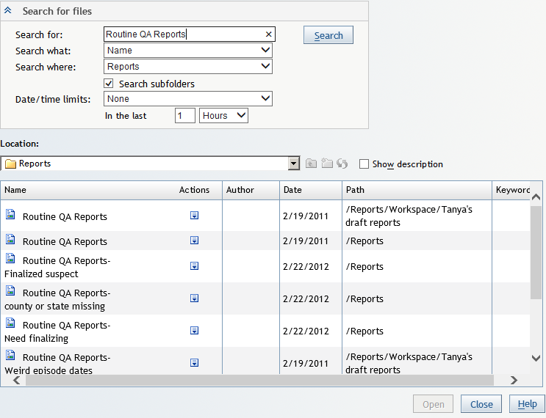
- Routine QA Reports – Contains three sub reports; each are subdivided by jurisdiction.
  - Finalized Suspect – Provides a report of all cases that Local Health Departments can set to the ‘Final’ status that have a Process Status of ‘Final’ and Resolution Status of ‘Suspect.’
  - County or State missing – Provides two reports; one that is for cases that are missing both State and County information, and one for cases that have WI listed as the State but is missing County information.
  - Need finalizing – Provides a report for cases that been created over 60 days ago with a Process Status not equal to ‘Sent to State’ or ‘Final’.
- Routine QA Reports–Finalized suspect - Provides a report of all cases that Local Health Departments can set to the ‘Final’ status that have a Process Status of ‘Final’ and Resolution Status of ‘Suspect’.
- Routine QA Reports–County or state missing - Provides two reports: one for cases that are missing both State and County information, and one for cases that have WI listed as the State but are missing County information. Each report is subdivided by jurisdiction.
- Routine QA Reports–Need finalizing - Provides a report for cases created more than 60 days ago with a Process Status not equal to ‘Sent to State’ or ‘Final’. The report is subdivided by jurisdiction.
- Routine QA Reports–Unknown or blank race ethnicity – Provides a list of ‘Confirmed’ and ‘Probable’ cases that have unknown or blank race or ethnicity data.
- Routine QA Reports–Weird episode dates – Provides four reports that are subdivided by jurisdiction.
  - Disease reports received in the current year with an ‘Episode Date’ before the previous year.
  - Disease reports with an ‘Episode Date’ in the future.
  - Disease reports with an ‘Episode Date’ prior to 1993 (not Hepatitis B).
  - Hepatitis B reports with an ‘Episode Date’ prior to 1980.

Creating New Reports
To create new reports, click on the ‘Web Report Studio’ option on the Home tab.

Creating Reports without the Report Wizard
To create reports from scratch, click on the ‘New’ or ‘New report’ links on the ‘Getting Started’ screen.
To select the data source (i.e. WEDSS_Cube or WEDSS_QA) and data elements that you want to use, navigate to the ‘Data’ menu and select the ‘Select Data…’ option.
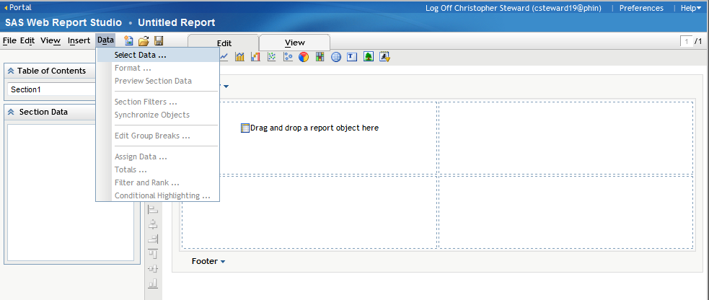
A pop up will appear for you to make your data selections. To change your data source, click the ‘Select Data Source…’ button.
- The WEDSS_Cube has data related to case counts, incidence rates, and percentages.
- The WEDSS_QA has de-identified case level data.
After selecting the data source, select the data items that you want included in your report by highlighting the item in the ‘Available data items:’ area and clicking the single arrow in the middle of the screen. You have all of the items that you need displayed in the ‘Selected data item:’ area, click the ‘OK’ button.
If at a later time you need to add or remove data items to or from your report, re-access the ‘Select Data Item’ area and add/remove additional data items as needed.
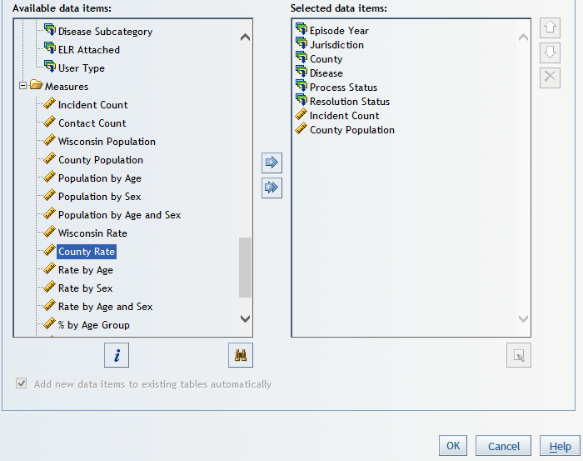
V
V
The data items selected are displayed on the left hand side of the screen.
The icons at the top of the screen represent the various ways to display your data. Below are some of the more common report objects used:
- Insert list
- Insert crosstab
- Insert bar chart
- Insert line graph
- Insert line-bar chart
- Insert pie chart
- Insert geographical map
- Insert text
To add a report object, click on the icons or drag and drop the icon to one of the outlined quadrants under the ‘Header’ section labelled “Drag and drop a report object here.”

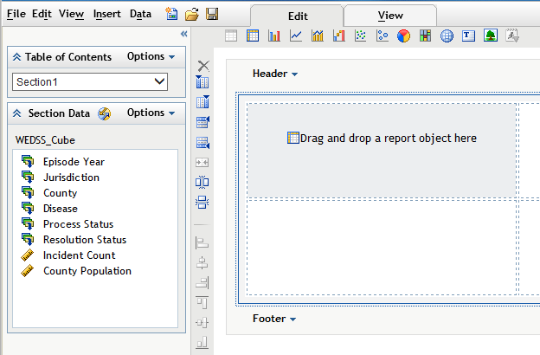
These icons allow you to format the report area by adding rows, columns, merging and splitting areas, and formatting the alignment of the objects in their area.

To add a report object, click on the icons or drag and drop the icon to one of the outlined quadrants under the ‘Header’ section labelled “Drag and drop a report object here”.
The data items selected are displayed on the left side.

The icons at the top of the screen represent the various ways to display your data.
Use the icons on the left side to format the report area by adding additional rows, columns, merging and splitting areas, and formatting the alignment of the objects in their area.
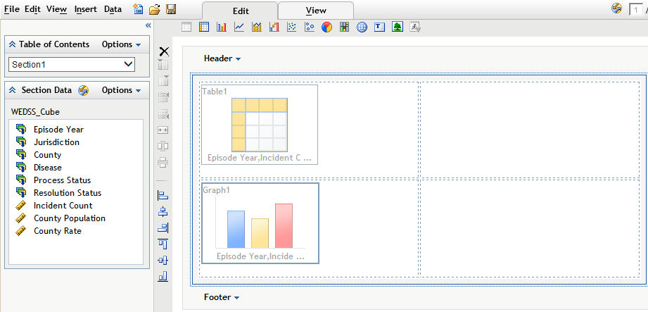
To add ‘Group Breaks’ to your report, click on the ‘Options’ menu item in the ‘Table of Contents’ area and select the ‘Group Breaks…’ item.
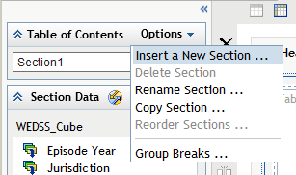
A ‘Group Break’ acts similarly to a filter; however, it will create a number of reports, each showing a different value for the data item selected. When viewing the report, you will have the option to select which value you want to ‘Group Break’ by.
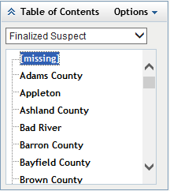
Note: It is recommended to have only one ‘Group Break’ in a report.

Using Templates
You can use a template to pre-set the general layout of a new report. There are a number of pre-made templates or you can create and save your own customized templates.

Using the Report Wizard
The Report Wizard can be used to assist with the initial creation of a report.
The first screen allows you to select the data that you want in your report.
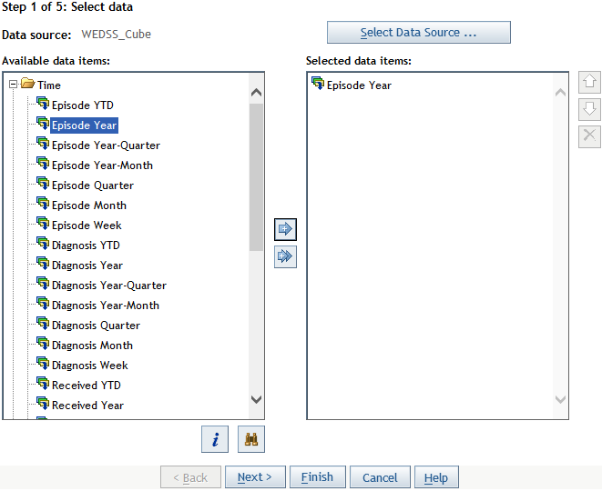
To select a different data source, click the ‘Select Data Source’ button. The WEDSS_Cube and WEDSS_QA are the most useful for creating reports.
- The WEDSS_Cube has data related to case counts, incidence rates, and percentages.
- The WEDSS_QA has de-identified case level data.

In the ‘Available data items:’ area you can select various data elements to display or to filter by. To select an item, highlight the item and use the single arrow in the middle of the screen to add it to the ‘Selected data items:’ area. After you have selected all of the items that you want to use, click the ‘Next’ button twice to go to Step 3 (there is nothing you are able to do in Step 2).
Note: To include additional data elements, select the appropriate ‘Available Data Items’ field. For instance, to include County Population or County Rate, select County, or to include demographic information, select Age, Sex, Race, and Ethnicity options.
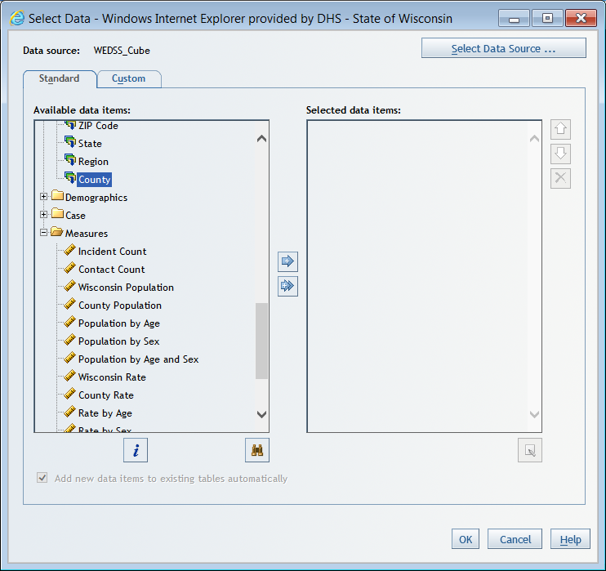
Step 3 allows you to define a ‘Group Break’ with one of your selected data items. A ‘Group Break’ acts similarly to a filter; however, it will create a number of reports, each showing a different value for the data item selected. Typical statewide reports created by WEDSS staff have Jurisdiction set as a ‘Group Break’. When viewing the report, you will have the option to select the values you want to ‘Group Break’ by.
Note: It is recommended to have only one ‘Group Break’ in a report.
Once you have selected your option, click the ‘Next’ button.
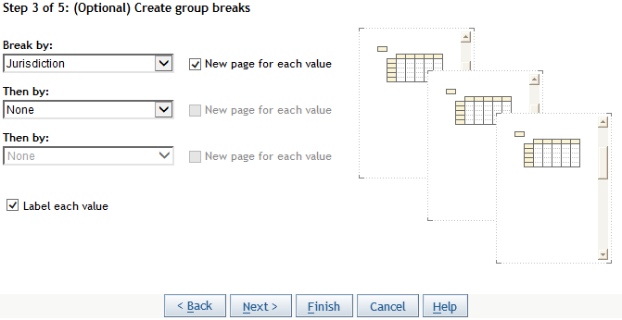
Step 4 allows you select options for displaying information in a Table or a Graph. Limited options are available in Step 4, but they can be modified later. When you have finished making your selections, click the ‘Next’ button.
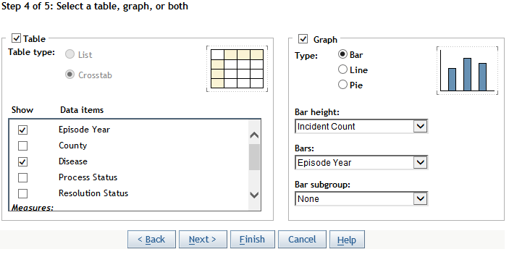
Step 5 allows you to add text to the header and footer of your report. When you have finished entering your desired header/footer text, click the ‘Finish’ button.
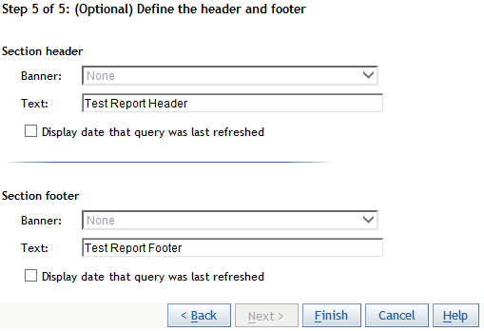
AVR will then create the basic elements of the report. You can now further filter and rearrange the data as needed.

Editing Reports
To assign content to be presented in your report, right-click on the report object and select the ‘Assign Data…’ option.
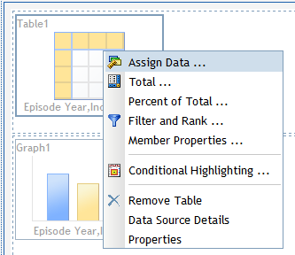
A pop up will appear that will prompt you to select the data you want included in your report. The data options available for you to select will depend on the report object that you are using. Below are examples for the crosstab and bar chart. Move the location of the data items by clicking and dragging or by selecting the ‘Move Items’ button. Move items that do you not want displayed to ‘Hidden.’ Once you have moved your items to their desired location, click the ‘OK’ button.
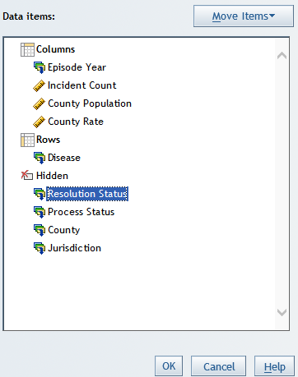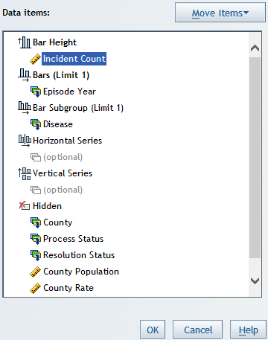

To filter the data, right-click any of the report objects and select ‘Filter and Rank…’ Filters applied to one object will transfer to all of the objects.
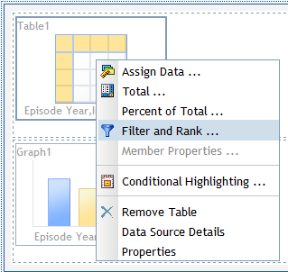
A pop up will appear that will prompt you to add filters to each of the available data items. You can only filter the ”category” data items (e.g. Disease) that are not designated as a ‘Group Break’. You can filter and rank your “measures” data items (e.g. Incident count) when viewing the report.
To filter a data item, select the item from the ‘Categories:’ list and select the ‘Filter’ radio button. Select the values listed in the ‘Available values:’ area that you want included and click the arrow button to move them to the ‘Selected values:’ area.
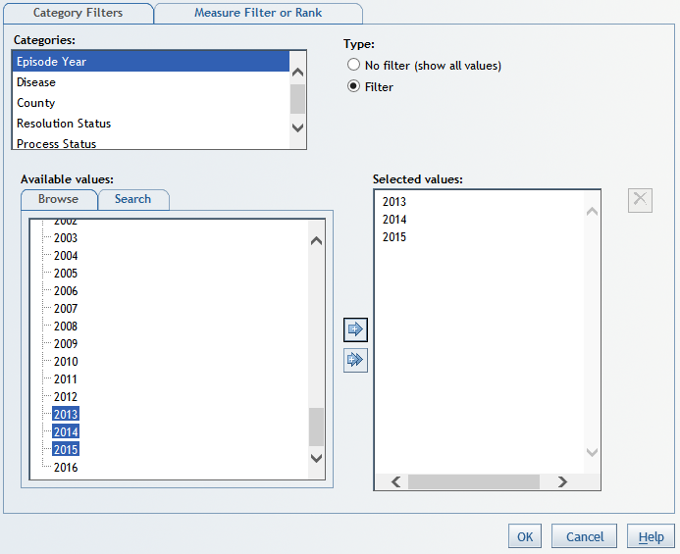
Once you have applied the desired filters, click the ‘OK’ button.
For crosstab tables, add total and sub-totals for rows and columns by right-clicking on the report object and selecting the ‘Totals…’ option.
You can add text in either the header or the footer to summarize the report. To add text, click on the header or footer and select the ‘Edit…’ option. When you are finished entering the desired text, click the ‘OK’ button.

Viewing Reports
To view the report that you compiled, click on the ‘View’ tab.
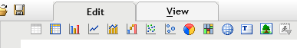
The report will then be rendered with the information that you selected.
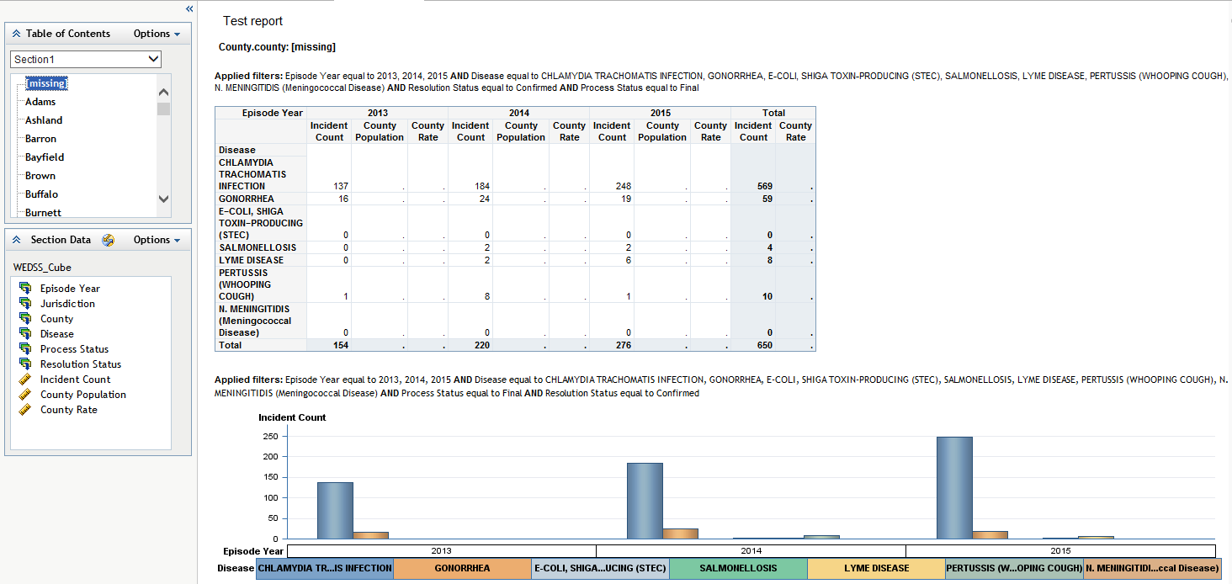
The ‘Group Break’ option is located in the ‘Table of Contents’ area.
There are a number of format and layout modifications that can be made to the report object:
- Right-click on a column header to sort, move, or set the alignment for the column
- Right-click on the data to reassign data items, add and remove totals, modify filters, modify ranking, and to rotate the table.
You can only have one filter or rank of a measure per report object. Filtering allows you to display only specific values (e.g. you wish to exclude a disease with a zero incident count). Ranking allows you to display the top or bottom number (or percent) of a given measure (e.g. top ten disease incident counts).
If you do not want to display ‘Applied Filters:’ on the report, go to the ‘View’ menu and un-select ‘Applied Filters.’
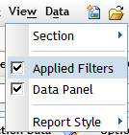
You can change the format of various report objects by right-clicking on data in the report and selecting the ‘Properties’ option. This will open a pop-up that will prompt you to adjust the various text and color options.
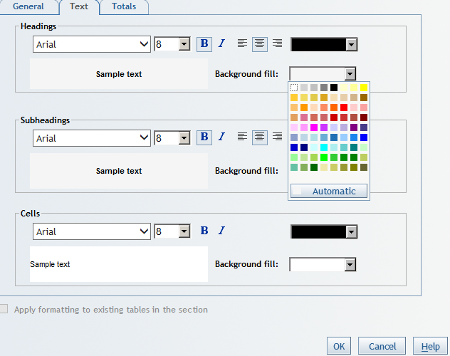
There are four pre-set styles to choose from in the ‘View’ menu under ‘Report Style.’
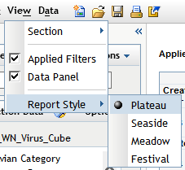

Saving Reports
To save a report, click on the ‘Save’ icon or go to the ‘File’ menu in AVR and select ‘Save’ or ‘Save As.’
Make sure you save the file in the ‘My Folder’ location and use a filename that is descriptive and easily identifiable. Reports saved in your ‘My Folder’ are only accessible by you.
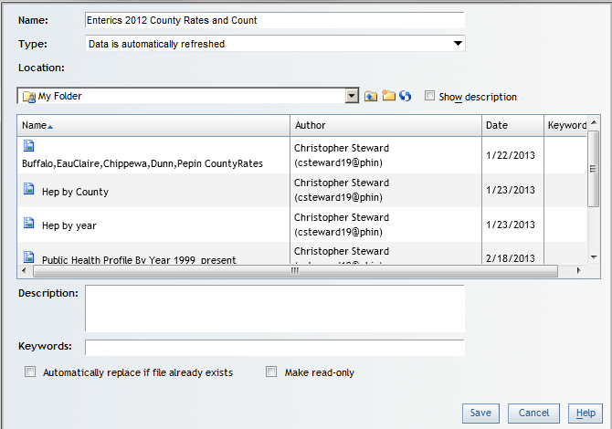
If you want to create a report that others can access and edit, create a folder in the WEDSS\Reports\Workspace folder and save your report there. Again, the name of the folder and the report should be descriptive and easily identifiable.

Exporting Reports
There are two ways to export data from AVR:
1. To export a single report object, right-click on the object and select the ‘Export Table’ option.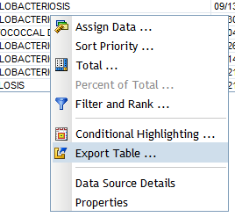
This will open a pop up that allows you to export the data in that report object to Excel or Word, or save the data as a TSV or CSV file.
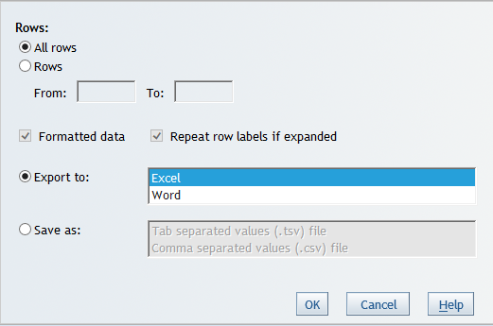
2. If you want to export the entire report, navigate to the ‘File’ menu and select the ‘Export…’ option.
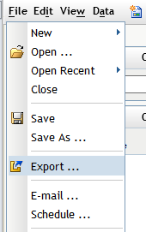
This will open a pop up window which will prompt you to open or save the folder that was generated. Select the ‘Save As’ option and designate a location that you want to save the folder to. The folder is a ‘Compressed Zipped Folder,’ so you will need to right-click on the saved folder and select the ‘Extract All’ option.
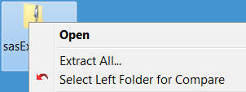
A new folder will then be generated. Open the new folder and click on the ‘sasExport’ Excel file inside to open the report.

