Risk Assessment Report
For the property at:
Click or tap to enter street address, Click or tap to enter apartment or unit number
Click or tap to enter city, WI Click or tap to enter zip code
Constructed in Click or tap to enter date of construction

Owned by:
Click or tap to enter owner name
Click or tap to enter mailing address Click or tap to enter city, Click or tap to enter state Click or tap to enter zip code
Click or tap to enter phone number

Risk assessment and report completed by:  Click or tap to enter name  Lead Risk Assessor, DHS No. Click or tap to enter lead risk assessor’s DHS number  Click or tap to enter direct phone number |  |  | Risk assessment and report assisted by:  Click or tap to enter name,  Choose discipline, DHS No. Click or tap to enter assistant’s DHS number  Click or tap to enter direct phone number
Signature date |  |  | Signature Date
Click or tap to enter company name, DHS No. Click or tap to enter company DHS number
Click or tap to enter street address
Click or tap to enter city, Click or tap to enter state Click or tap to enter zip code
Click or tap to enter phone number

Date of risk assessment: Select drop down to enter a date.
Date of report: Select drop down to enter a date.

Table of Contents
1.0 Purpose and key findings 4
1.1 Lead risk assessment 4
2.0 Property owner’s next actions 5
2.1 Control the hazards 5
2.2 Monitor and Maintain 6
2.3 Disclose this report to future purchasers and renters of this property 7
3.0 Methods 8
3.1 Visual assessment 8
3.2 Paint inventory 8
3.3 Paint Testing 8
3.4 Dust analysis 8
3.5 Soil analysis 9
3.6 Consumer product assessment 9
4.0 Limitations 10
5.0 Background information 10
5.1 Physical characteristics of the property 10
5.2 Previous lead investigations 10
5.3 Building maintenance and renovations 11
5.4 Building condition assessment 11
5.5 Occupant information 12
6.0 Full results 12
6.1 Visual assessment, paint inventory and paint test results (XRF) 12
6.2 Paint chip sampling results 16
6.3 Dust analysis results 17
6.4 Soil analysis results 18
6.5 Consumer products assessment 18
Appendix A: XRF and Calibration Information 20
Appendix B: Laboratory Analysis Report(s) 23
Appendix C: Floor Plan(s) and Site Sketch 24
Appendix D: Pictures 25
Appendix E: Ongoing Monitoring 28

Purpose and key findings
This report is the result of a lead risk assessment in a property Choose option. Lead risk assessments are regulated by the Wisconsin Department of Health Services (DHS) under Wis. Admin. Code ch. DHS 163.

1.1 Lead risk assessment
A lead risk assessment identifies lead-based paint hazards: lead-based paint that is deteriorated, subject to friction or impact, or has evidence of chewing, as well as areas of bare soil. This report includes information on all lead hazards found, as well as recommendations for
controlling each hazard, with detailed instructions on the work required to do so. Hazards were found in this property in the following locations:
Lead-based paint hazards
Room equivalent | Substrate | Component and location
- Click or tap to enter room equivalent | Select substrate | Click or tap to enter component(s) and location
- Click or tap to enter room equivalent | Select substrate | Click or tap to enter component(s) and location
- Click or tap to enter room equivalent | Select substrate | Click or tap to enter component(s) and location
- Click or tap to enter room equivalent | Select substrate | Click or tap to enter component(s) and location
- Click or tap to enter room equivalent | Select substrate | Click or tap to enter component(s) and location
- Click or tap to enter room equivalent | Select substrate | Click or tap to enter component(s) and location
- Click or tap to enter room equivalent | Select substrate | Click or tap to enter component(s) and location
- Click or tap to enter room equivalent | Select substrate | Click or tap to enter component(s) and location

Dust lead hazards
Click or tap to indicate whether floors were determined to be dust hazards
Click or tap to indicate whether windowsills were determined to be dust hazards

Soil lead hazards
Click or tap to indicate whether soil lead hazards were identified in children’s play areas.
Click or tap to indicate whether soil lead hazards were identified in the dripline
Click or tap to indicate whether soil lead hazards were identified in other non-play area, non-dripline areas of the yard.

For a description of the process used to determine the presence of lead-based paint hazards, see Methods. For recommendations to control the hazards identified during this assessment, see Control the Hazards.

2.0 Property owner’s next actions
☐ Review the report and call the risk assessor if you have questions.
☐ Give current and future residents a copy of this report.
☐ Save a copy of this report for future purchasers of this property. This report must be disclosed prior to the sale.
☐ Keep kids away from hazards. Click or tap to provide directions for immediate actions to take now, such as to HEPA vacuum and wet clean if dust lead hazards are present, or to use duct tape, furniture, or other barriers to keep kids from chewing painted surfaces.
☐ Address underlying conditions. Click or tap to describe conditions that will affect substrate stability, causing paint failure, if not corrected prior to implementing controls (e.g. leaking roof, bathroom ventilation).
☐ Hire a Wisconsin-certified lead company to control the hazards. You can find a certified company in your area using the Wisconsin Department of Health Services’ online search tool.

2.1 Control the hazards
There are a range of control options for addressing the lead hazards identified through this investigation.
The checked box marks the recommended control, where applicable.
Interim controls may be more affordable in the short-term, but are only temporary, so will be an ongoing expense. These can be performed by a certified company with a lead-safe renovator, abatement worker, or abatement supervisor overseeing the job.

Abatement may be more expensive initially, but these measures are expected to last at least 20 years. Abatement must be conducted by a certified company with a full crew of abatement-certified staff working on the job.

If you want to keep it simple, a lead company with abatement crew can do all the work. You can find a Wisconsin-certified company using the Wisconsin Department of Health Services’ online search tool.

Note: The hazard control options listed below are for the lead hazards identified in this report only and require Wisconsin lead discipline trained and certified contractors to perform the remediation work properly. The identified lead hazards may be associated with asbestos-containing materials that require proper Wisconsin asbestos certifications to properly perform the remediation work, in addition to the Wisconsin lead certifications.

Lead-safe work practices are always required!

- Paste component and effected room equivalent(s) for this hazard number from the Lead Risk Assessment key findings tables.
Interim Control  Click or tap here to enter text to describe interim control option(s). For example, “Repair or replace all areas of damaged or rotten wood. Wet scrape all loose, peeling, cracked, or blistered paint. Repaint to smooth and cleanable condition.” | Click or tap to enter text to describe why you recommend one control over another or delete this text box. For example, “Abatement is recommended because the interim control option will be a lot of work and won’t last long due to friction and moisture.”  Abatement ☑  Click or tap to enter text describe abatement control option(s). For example, “Remove and replace existing window with new vinyl replacement window unit sized to fit the existing opening. Outer stops, trim, and stools are to be replaced with new or wrapped with aluminum cladding.”

Room: Click or tap to enter room equivalent
Component | Hazard control option (interim control) | Hazard control option (abatement) ☑
Click or tap to enter component | Click or tap to choose hazard control option | Click or tap to choose hazard control option
Click or tap to enter component | Click or tap to choose hazard control option | Click or tap to choose hazard control option
Click or tap to enter component | Click or tap to choose hazard control option | Click or tap to choose hazard control option
Notes: Click or tap to enter hazard control options not listed in the table

2.2 Monitor and maintain
Since lead-based paint is present, lead-based paint hazards could develop. Surfaces with lead-based paint should be regularly monitored. This may be done by an owner-occupant, a certified risk assessor or hazard investigator by looking for any areas of new deterioration, rot, substrate, or component failure due to leaking gutters, missing downspouts, leaking roofs or pipes. If any are found, a certified company with properly trained and certified staff can make needed repairs using lead-safe methods. Find a contractor using the Wisconsin Department of Health Services’ online search tool. For a detailed maintenance and monitoring schedule, see Appendix E: Ongoing Monitoring.

2.3 Disclose this report to future purchasers and renters of this property
Provide a copy of this report, along with a copy of the educational pamphlet, Protect Your Family from Lead in Your Home, to potential tenants or purchasers of this property before they become obligated under a sales contract or lease. More information on complying with this federal regulation is available at Lead-Based Paint Disclosure Rule (Section 1018 of Title X).

3.0 Methods

3.1 Visual assessment
Before any testing was done, the risk assessor carefully looked at the property to find any potential lead hazards. The risk assessor developed a list of each instance of a painted or coated surface with:
- Deteriorated paint (for example, paint that is chipping, peeling, or cracking).
- Friction forces (for example, a window sash sliding up and down against jambs and stops).
- Impact forces (for example, a door panel striking a door stop).
- Evidence of chewing (for example, teeth marks on a window sill).
- A failing substrate (for example, rotted wood from moisture).

Surfaces identified as potential lead hazards through the visual assessment process are identified as “deteriorated” in the Results table under the Condition heading. The risk assessor also evaluated the building’s condition to determine the root cause of any major substrate failure and/or paint deterioration. See the Building condition assessment for additional details. The risk assessor inspected the grounds on the property’s exterior for any instances of bare soil.

3.2 Paint inventory
Before testing, the risk assessor prepared an inventory of painted or coated surfaces. For each “room equivalent” in the dwelling, including all interior and exterior common areas, the risk assessor listed each painted component, grouping together (following the HUD Guidelines) any surfaces with the same substrate (brick, concrete, drywall, metal, plaster, or wood) that are likely to share a similar paint history. From this inventory, the risk assessor selected at least one test location for each surface with a distinct paint history.

3.3 Paint testing
The risk assessor followed the documented methodologies (for example, the HUD Guidelines) to identify all surfaces with distinct paint history for testing. A Click or tap to enter the XRF Manufacturer and Model X-ray fluorescence (XRF) instrument, serial number Click or tap to enter the serial number, was used to test each of these surfaces. For additional details on the procedures used for paint analysis, see APPENDIX A: XRF and Calibration.

The results of paint analyses were used to determine the presence of lead-based paint hazards for surfaces identified as deteriorated in the Condition column of the Results table.

3.4 Dust analysis
Single-surface dust-wipe samples were collected from windowsills and floors, following documented protocol and sampling methodologies found in Wis. Admin. Code ch. DHS 163 and Appendix 13.1: Wipe Sampling of Settled Dust for Lead Determination, of the HUD Guidelines.

The results of dust analyses were used to determine the presence of dust lead hazards.

3.5 Soil analysis
The risk assessor inspected exterior play areas, the “dripline” area next to the foundation, and the rest of the yard for bare soil. Bare soil was found Click or tap to enter text describing where bare soil was found. The soil was sampled and analyzed for lead concentration following documented protocol and sampling methodologies found in Wis. Admin. Code ch. DHS 163 and Appendix 13.3, Collecting Soil Samples for Lead Determination of the HUD Guidelines to find out if lead soil levels were hazardous.

The risk assessor inspected exterior play areas, the “dripline” area next to the foundation, and the rest of the yard for bare soil. There was no bare soil, so soil analysis was not conducted.

Because there was snow on the ground, the risk assessor was unable to inspect exterior play areas, the “dripline” area next to the foundation, or the rest of the yard for bare soil. Soil lead hazards may be present. The yard should be reinspected for bare soil after the snow melts, and if any is found, it should be sampled and analyzed for lead concentration following documented protocol and sampling methodologies found in Wis. Admin. Code ch. DHS 163 and Appendix 13.3, Collecting Soil Samples for Lead Determination of the HUD Guidelines in each of the following areas to determine if lead soil levels are hazardous:
- Children’s play areas
- The rest of the yard
- The foundation and dripline area

3.6 Consumer product assessment
Consumer product assessments are only conducted as part of an environmental investigation or elevated blood lead level investigation (EBLL) by local health departments or by risk assessors contracted by a local health department. The risk assessor administered Form 16.1, Resident Questionnaire for the Investigation of Children with Elevated Blood Lead Levels (EBL), of the HUD Guidelines. The personal items listed below may be a potential source of lead exposure:
- Make-up
- Candy
- Toys
- Cribs
- Antiques
- Hunting and fishing equipment

4.0 Limitations
The findings in this report are based on the conditions observed on the date of the investigation. Because conditions may change over time, it is important that the property owner monitor all surfaces that are positive for lead. Any changes could make the surface a lead-hazard that should be addressed with a lead hazard control measure. HUD considers a risk assessment conducted within the past twelve months to be current.

Some surfaces could not be fully assessed or inspected because they were inaccessible. For example, carpeted flooring is not tested, and lead-based paint could be present underneath. These surfaces are noted by room in the Results section in the Room Notes table.

All areas were/were not accessible. The following areas were not accessible: Click or tap here to list areas that were inaccessible and not assessed. Lead hazards may be present. Children under the age of six should not be allowed in these areas until it has been assessed by a certified lead risk assessor or lead hazard investigator.

This risk assessment only identifies lead hazards present at this property. Children can be exposed to lead wherever they spend time. In addition, dust from contaminated work clothes and shoes, glazed pottery, certain home remedies and traditional cosmetics, imported candies, toy jewelry, and hobby supplies may contain lead. For additional information on sources of lead, visit CDC's Sources of Lead Exposure webpage.

This risk assessment is not a comprehensive investigation for other hazardous materials (for example, asbestos) or building conditions (for example, Housing Quality Standards [HQS]). Further analysis by properly trained and certified investigators is needed to make informed decisions about these latter conditions.

5.0 Background information

5.1 Physical characteristics of the property
Click or tap to describe physical characteristics of the property (for example, “The property is a two-unit [upper/lower] home built in 1907. The upper unit, the common areas in the basement and back hallway, as well as the exterior of the property, were assessed. The property has no garage or other outbuildings.”

Click or tap to describe neighboring properties (for example, “The property is bordered by__ street on the east, and residential properties on the south, west and north sides.”

5.2 Previous lead investigations
Click or tap to describe any previous lead investigations conducted at the property that the risk assessor relied on for any findings in this report. Example: No previous lead-based paint inspections or risk assessments of this property were known to exist at the time of this assessment.

5.3 Building maintenance and renovations
Click or tap to describe any significant observations about the maintenance or remodeling history of the property (for example,” The property has been resided with vinyl and one window [window 10] has been replaced with a vinyl insert. There is significant water damage to painted surfaces throughout the home’s walls and ceilings, as well as to the woodwork around the bathroom window [window 12], and it is not clear how long that has been an issue.”)

5.4 Building condition assessment
Because building conditions, such as a roof leak, could impact the success of future hazard control options, the assessor also looked for potential underlying causes for deterioration.
Note: Any building material that is not wood, metal, fiberglass, or glass may contain asbestos.

Question | Answer | Comment
- Roof missing parts of surfaces (tiles, boards, shakes, etc.)? | Select yes/no | If yes, click or tap to describe (for example, “Roof causing significant leaking into home.”)
- Roof has holes or large cracks | Select yes/no | If yes, click or tap to describe
- Gutters or downspouts broken? | Select yes/no | If yes, click or tap to describe
- Chimney masonry cracked, bricks loose or missing, obviously out of plumb? | Select yes/no | If yes, click or tap to describe
- Exterior or interior walls have obvious large cracks or holes, requiring more than routine pointing (if masonry) or painting? | Select yes/no | If yes, click or tap to describe
- Exterior siding has missing boards or shingles? | Select yes/no | If yes, click or tap to describe
- Water stains on interior walls or ceilings? | Select yes/no | If yes, click or tap to describe
- Walls or ceilings deteriorated? | Select yes/no | If yes, click or tap to describe
- More than very small amount of paint in a room deteriorated? | Select yes/no | If yes, click or tap to describe
- Two or more windows or doors broken, missing, or boarded up? | Select yes/no | If yes, click or tap to describe
- Porch or steps have major elements broken, missing, or boarded up? | Select yes/no | If yes, click or tap to describe
- Foundation has major cracks, missing material, structure leans, or visibly unsound? | Select yes/no | If yes, click or tap to describe

5.5 Occupant information
Click or tap to describe relevant occupant use patterns (for example, “The upper unit is occupied by one child under the age of 6. The child sleeps in the rear bedroom and has access to the whole apartment. The family dog goes in and out of the house to the yard through the back kitchen exit.”)

6.0 Full results

6.1 Visual assessment, paint inventory and paint test results (XRF)
The findings in this report are based on the Federal definition of lead-based paint: Lead-based paint means paint or other surface coatings that contain lead equal to or in excess of 1.0 milligrams per square centimeter or more than 0.5 percent by weight.

The full lead-based paint inspection and risk assessment results that follow are organized by room, followed by a section on dust wipe sampling results. Calibration readings and the performance characteristics sheet of the X-ray fluorescence (XRF) instrument used for this investigation is provided in APPENDIX A: XRF and Calibration.
Click or tap to enter room equivalent name

Reading number | Substrate | Component(s)  represented | Test location  (if more specific) | Side | Result  (mg/cm²) | Condition | Condition type | LBP  hazard?
Click or tap to enter reading # | Select substrate | Click or tap to add | Click or tap to add | Select side | Enter value | Select condition | Choose condition type. | Select yes/no
Click or tap to enter reading # | Select substrate | Click or tap to add | Click or tap to add | Select side | Enter value | Select condition | Choose condition type. | Select yes/no
Click or tap to enter reading # | Select substrate | Click or tap to add | Click or tap to add | Select side | Enter value | Select condition | Choose condition type. | Select yes/no
Click or tap to enter reading # | Select substrate | Click or tap to add | Click or tap to add | Select side | Enter value | Select condition | Choose condition type. | Select yes/no
Click or tap to enter reading # | Select substrate | Click or tap to add | Click or tap to add | Select side | Enter value | Select condition | Choose condition type. | Select yes/no
Click or tap to enter reading # | Select substrate | Click or tap to add | Click or tap to add | Select side | Enter value | Select condition | Choose condition type. | Select yes/no
Click or tap to enter reading # | Select substrate | Click or tap to add | Click or tap to add | Select side | Enter value | Select condition | Choose condition type. | Select yes/no
Click or tap to enter reading # | Select substrate | Click or tap to add | Click or tap to add | Select side | Enter value | Select condition | Choose condition type. | Select yes/no

Room notes - Click or tap to enter room notes

Substrate | Components | Condition | Condition type | Reason not tested
Select substrate | Click or tap to add | Select condition | Choose condition type. | Click or tap to enter reason not tested
Select substrate | Click or tap to add | Select condition | Choose condition type. | Click or tap to enter reason not tested
Select substrate | Click or tap to add | Select condition | Choose condition type. | Click or tap to enter reason not tested
Select substrate | Click or tap to add | Select condition | Choose condition type. | Click or tap to enter reason not tested
Select substrate | Click or tap to add | Select condition | Choose condition type. | Click or tap to enter reason not tested
Select substrate | Click or tap to add | Select condition | Choose condition type. | Click or tap to enter reason not tested

Click or tap to enter room equivalent name

Reading number | Substrate | Component(s)  represented | Test location  (if more specific) | Side | Result  (mg/cm²) | Condition | Condition type | LBP  hazard?
Click or tap to enter reading # | Select substrate | Click or tap to add | Click or tap to add | Select side | Enter value | Select condition | Choose condition type. | Select yes/no
Click or tap to enter reading # | Select substrate | Click or tap to add | Click or tap to add | Select side | Enter value | Select condition | Choose condition type. | Select yes/no
Click or tap to enter reading # | Select substrate | Click or tap to add | Click or tap to add | Select side | Enter value | Select condition | Choose condition type. | Select yes/no
Click or tap to enter reading # | Select substrate | Click or tap to add | Click or tap to add | Select side | Enter value | Select condition | Choose condition type. | Select yes/no
Click or tap to enter reading # | Select substrate | Click or tap to add | Click or tap to add | Select side | Enter value | Select condition | Choose condition type. | Select yes/no
Click or tap to enter reading # | Select substrate | Click or tap to add | Click or tap to add | Select side | Enter value | Select condition | Choose condition type. | Select yes/no
Click or tap to enter reading # | Select substrate | Click or tap to add | Click or tap to add | Select side | Enter value | Select condition | Choose condition type. | Select yes/no
Click or tap to enter reading # | Select substrate | Click or tap to add | Click or tap to add | Select side | Enter value | Select condition | Choose condition type. | Select yes/no

Room notes - Click or tap to enter room notes

Substrate | Components | Condition | Condition type | Reason not tested
Select substrate | Click or tap to add | Select condition | Choose condition type. | Click or tap to enter reason not tested
Select substrate | Click or tap to add | Select condition | Choose condition type. | Click or tap to enter reason not tested
Select substrate | Click or tap to add | Select condition | Choose condition type. | Click or tap to enter reason not tested
Select substrate | Click or tap to add | Select condition | Choose condition type. | Click or tap to enter reason not tested
Select substrate | Click or tap to add | Select condition | Choose condition type. | Click or tap to enter reason not tested
Select substrate | Click or tap to add | Select condition | Choose condition type. | Click or tap to enter reason not tested

Click or tap to enter room equivalent name

Reading number | Substrate | Component(s)  represented | Test location  (if more specific) | Side | Result  (mg/cm²) | Condition | Condition type | LBP  hazard?
Click or tap to enter reading # | Select substrate | Click or tap to add | Click or tap to add | Select side | Enter value | Select condition | Choose condition type. | Select yes/no
Click or tap to enter reading # | Select substrate | Click or tap to add | Click or tap to add | Select side | Enter value | Select condition | Choose condition type. | Select yes/no
Click or tap to enter reading # | Select substrate | Click or tap to add | Click or tap to add | Select side | Enter value | Select condition | Choose condition type. | Select yes/no
Click or tap to enter reading # | Select substrate | Click or tap to add | Click or tap to add | Select side | Enter value | Select condition | Choose condition type. | Select yes/no
Click or tap to enter reading # | Select substrate | Click or tap to add | Click or tap to add | Select side | Enter value | Select condition | Choose condition type. | Select yes/no
Click or tap to enter reading # | Select substrate | Click or tap to add | Click or tap to add | Select side | Enter value | Select condition | Choose condition type. | Select yes/no
Click or tap to enter reading # | Select substrate | Click or tap to add | Click or tap to add | Select side | Enter value | Select condition | Choose condition type. | Select yes/no
Click or tap to enter reading # | Select substrate | Click or tap to add | Click or tap to add | Select side | Enter value | Select condition | Choose condition type. | Select yes/no

Room notes - Click or tap to enter room notes

Substrate | Components | Condition | Condition type | Reason not tested
Select substrate | Click or tap to add | Select condition | Choose condition type. | Click or tap to enter reason not tested
Select substrate | Click or tap to add | Select condition | Choose condition type. | Click or tap to enter reason not tested
Select substrate | Click or tap to add | Select condition | Choose condition type. | Click or tap to enter reason not tested
Select substrate | Click or tap to add | Select condition | Choose condition type. | Click or tap to enter reason not tested
Select substrate | Click or tap to add | Select condition | Choose condition type. | Click or tap to enter reason not tested
Select substrate | Click or tap to add | Select condition | Choose condition type. | Click or tap to enter reason not tested

Click or tap to enter room equivalent name

Reading number | Substrate | Component(s)  represented | Test location  (if more specific) | Side | Result  (mg/cm²) | Condition | Condition type | LBP  hazard?
Click or tap to enter reading # | Select substrate | Click or tap to add | Click or tap to add | Select side | Enter value | Select condition | Choose condition type. | Select yes/no
Click or tap to enter reading # | Select substrate | Click or tap to add | Click or tap to add | Select side | Enter value | Select condition | Choose condition type. | Select yes/no
Click or tap to enter reading # | Select substrate | Click or tap to add | Click or tap to add | Select side | Enter value | Select condition | Choose condition type. | Select yes/no
Click or tap to enter reading # | Select substrate | Click or tap to add | Click or tap to add | Select side | Enter value | Select condition | Choose condition type. | Select yes/no
Click or tap to enter reading # | Select substrate | Click or tap to add | Click or tap to add | Select side | Enter value | Select condition | Choose condition type. | Select yes/no
Click or tap to enter reading # | Select substrate | Click or tap to add | Click or tap to add | Select side | Enter value | Select condition | Choose condition type. | Select yes/no
Click or tap to enter reading # | Select substrate | Click or tap to add | Click or tap to add | Select side | Enter value | Select condition | Choose condition type. | Select yes/no
Click or tap to enter reading # | Select substrate | Click or tap to add | Click or tap to add | Select side | Enter value | Select condition | Choose condition type. | Select yes/no

Room notes - Click or tap to enter room notes

Substrate | Components | Condition | Condition type | Reason not tested
Select substrate | Click or tap to add | Select condition | Choose condition type. | Click or tap to enter reason not tested
Select substrate | Click or tap to add | Select condition | Choose condition type. | Click or tap to enter reason not tested
Select substrate | Click or tap to add | Select condition | Choose condition type. | Click or tap to enter reason not tested
Select substrate | Click or tap to add | Select condition | Choose condition type. | Click or tap to enter reason not tested
Select substrate | Click or tap to add | Select condition | Choose condition type. | Click or tap to enter reason not tested
Select substrate | Click or tap to add | Select condition | Choose condition type. | Click or tap to enter reason not tested

Click or tap to enter room equivalent name

Reading number | Substrate | Component(s)  represented | Test location  (if more specific) | Side | Result  (mg/cm²) | Condition | Condition type | LBP  hazard?
Click or tap to enter reading # | Select substrate | Click or tap to add | Click or tap to add | Select side | Enter value | Select condition | Choose condition type. | Select yes/no
Click or tap to enter reading # | Select substrate | Click or tap to add | Click or tap to add | Select side | Enter value | Select condition | Choose condition type. | Select yes/no
Click or tap to enter reading # | Select substrate | Click or tap to add | Click or tap to add | Select side | Enter value | Select condition | Choose condition type. | Select yes/no
Click or tap to enter reading # | Select substrate | Click or tap to add | Click or tap to add | Select side | Enter value | Select condition | Choose condition type. | Select yes/no
Click or tap to enter reading # | Select substrate | Click or tap to add | Click or tap to add | Select side | Enter value | Select condition | Choose condition type. | Select yes/no
Click or tap to enter reading # | Select substrate | Click or tap to add | Click or tap to add | Select side | Enter value | Select condition | Choose condition type. | Select yes/no
Click or tap to enter reading # | Select substrate | Click or tap to add | Click or tap to add | Select side | Enter value | Select condition | Choose condition type. | Select yes/no
Click or tap to enter reading # | Select substrate | Click or tap to add | Click or tap to add | Select side | Enter value | Select condition | Choose condition type. | Select yes/no

Room notes - Click or tap to enter room notes

Substrate | Components | Condition | Condition type | Reason not tested
Select substrate | Click or tap to add | Select condition | Choose condition type. | Click or tap to enter reason not tested
Select substrate | Click or tap to add | Select condition | Choose condition type. | Click or tap to enter reason not tested
Select substrate | Click or tap to add | Select condition | Choose condition type. | Click or tap to enter reason not tested
Select substrate | Click or tap to add | Select condition | Choose condition type. | Click or tap to enter reason not tested
Select substrate | Click or tap to add | Select condition | Choose condition type. | Click or tap to enter reason not tested
Select substrate | Click or tap to add | Select condition | Choose condition type. | Click or tap to enter reason not tested

6.2 Paint chip sampling results
The findings in this report are based on the Federal definition of lead-based paint: Lead-based paint means paint or other surface coatings that contain lead equal to or in excess of 1.0 milligrams per square centimeter or more than 0.5 percent by weight.

Lead in paint, varnish, shellac, or other surface coatings can be identified by laboratory analysis of paint chips or by direct readings using an X-ray florescence (XRF) instrument. In this assessment, the contractor collected paint chip samples in accordance with Appendix 13.2, Paint Chip Sampling found in the HUD Guidelines for The Evaluation and Control of Lead Based Paint Hazards in Housing.

The assessor collected a total of Click or tap to enter number of samples paint chip samples for analysis by the:
Click or tap to enter name of laboratory
Click or tap to enter street address
Click or tap to enter city, state, and zip code
Click or tap to enter phone number
Laboratory ID # Click or tap to enter Laboratory ID #

Paint chip sampling summary table
Sample # | Substrate | Component | Location | Side | Result  (mg/cm² or %) | LBP? | LBP  hazard?
Click or tap to enter sample # | Select substrate | Click or tap to add component | Click or tap to add location | Select side | Enter value | Select yes/no | Select yes/no
Click or tap to enter sample # | Select substrate | Click or tap to add component | Click or tap to add location | Select side | Enter value | Select yes/no | Select yes/no
Click or tap to enter sample # | Select substrate | Click or tap to add component | Click or tap to add location | Select side | Enter value | Select yes/no | Select yes/no
Click or tap to enter sample # | Select substrate | Click or tap to add component | Click or tap to add location | Select side | Enter value | Select yes/no | Select yes/no
Click or tap to enter sample # | Select substrate | Click or tap to add component | Click or tap to add location | Select side | Enter value | Select yes/no | Select yes/no
Click or tap to enter sample # | Select substrate | Click or tap to add component | Click or tap to add location | Select side | Enter value | Select yes/no | Select yes/no
Click or tap to enter sample # | Select substrate | Click or tap to add component | Click or tap to add location | Select side | Enter value | Select yes/no | Select yes/no

6.3 Dust analysis results
The risk assessor collected Click or tap to enter number of dust wipes single surface wipe samples to find out if lead dust hazards were present on floors or windowsills.

A lead dust hazard is present if the arithmetic mean average of laboratory results for all like surfaces are equal to or are greater than 10 micrograms per square foot (µg/ft²) on a floor and 100 micrograms per square foot (µg/ft²) on a windowsill.

The Enter lab name Enter lab ID# , at Enter lab address Enter lab phone number analyzed samples, including a generically labeled “field blank” wipe submitted for quality control.

Wipe sampling summary table
Sample | Room equivalent | Surface | Result |  | Standard | Lead dust hazard?
Click or tap to enter sample # | Click or tap to enter room equivalent | Floor | Enter value | µg/ft² | ≥ 10 µg/ft² | Select yes/no
Click or tap to enter sample # | Click or tap to enter room equivalent | Sill | Enter value | µg/ft² | ≥ 100 µg/ft² | Select yes/no
Click or tap to enter sample # | Click or tap to enter room equivalent | Floor | Enter value | µg/ft² | ≥ 10 µg/ft² | Select yes/no
Click or tap to enter sample # | Click or tap to enter room equivalent | Sill | Enter value | µg/ft² | ≥ 100 µg/ft² | Select yes/no
Click or tap to enter sample # | Click or tap to enter room equivalent | Floor | Enter value | µg/ft² | ≥ 10 µg/ft² | Select yes/no
Click or tap to enter sample # | Click or tap to enter room equivalent | Sill | Enter value | µg/ft² | ≥ 100 µg/ft² | Select yes/no
Click or tap to enter sample # | Click or tap to enter room equivalent | Floor | Enter value | µg/ft² | ≥ 10 µg/ft² | Select yes/no
Click or tap to enter sample # | Click or tap to enter room equivalent | Sill | Enter value | µg/ft² | ≥ 100 µg/ft² | Select yes/no
Click or tap to enter sample # | Click or tap to enter room equivalent | Floor | Enter value | µg/ft² | ≥ 10 µg/ft² | Select yes/no
Click or tap to enter sample # | Click or tap to enter room equivalent | Sill | Enter value | µg/ft² | ≥ 100 µg/ft² | Select yes/no
Click or tap to enter sample # | Click or tap to enter room equivalent | Floor | Enter value | µg/ft² | ≥ 10 µg/ft² | Select yes/no
Click or tap to enter sample # | Click or tap to enter room equivalent | Sill | Enter value | µg/ft² | ≥ 100 µg/ft² | Select yes/no
Click or tap to enter sample # | Click or tap to enter room equivalent | Floor | Enter value | µg/ft² | ≥ 10 µg/ft² | Select yes/no
Click or tap to enter sample # | Quality control | Blank | Enter value | µg/ft² | ≥ 10 µg/ft² | Select pass/fail

The mean average of Click or tap to floor average µg/ft² is applied to all floors including those not tested. Since the average Choose is/is not equal to or greater than 10 µg/ft², Choose option

The mean average of Click or tap to enter window sill average µg/ft² is applied to all windowsills, including those not tested. Since the average Choose is/is not equal to or greater than 100 µg/ft², Choose option

The mean average does not apply to Choose floor/window sill in the Click or tap to enter rooms. These surfaces and all other like surfaces not sampled throughout the dwelling are considered to have dust hazards and will require corrective measures.

6.4 Soil analysis results
The risk assessor visually assessed the exterior of the property for areas of bare soil. No bare soil was present on the date of the assessment, so no samples were collected for analysis.

The assessor collected a total of Click or tap to enter number of soil samples composite samples for analysis by the Enter lab name, Laboratory ID #Enter lab ID# , at Enter lab address, Enter lab phone number.
Composite samples from children’s play areas, the area around the home’s foundation (dripline), and all other areas of bare soil in the yard were analyzed separately. In Wisconsin, a soil-lead hazard is present if the results are greater than or equal to 400 parts per million (ppm) for soil collected from a play area or 1,200 ppm for soil collected from other areas of the yard.

Soil sampling summary table
Sample | Soil Location | Result |  | Standard | Soil-Lead Hazard?
1 | Dripline | Click or tap to enter value | ppm | ≥ 1,200 ppm | Select yes/no
2 | Play areas | Click or tap to enter value | ppm | ≥ 400 ppm | Select yes/no
3 | Other | Click or tap to enter value | ppm | ≥ 1,200 ppm | Select yes/no

6.5 Consumer products assessment
The Consumer Product Safety Commission (CPSC) sets standards for the amount of lead allowed in the applied coatings on toys and furniture intended for use by children. The current CPSC standard for children’s toys, jewelry, clothing, furniture, and other children’s products is less than < 90 ppm of lead.

The assessor collected a total of click or tap to enter the number of samples bulk samples for analysis by the:
Click or tap to enter name of laboratory
Click or tap to enter street address
Click or tap to enter city, state, and zip code
Click or tap to enter phone number
Laboratory ID # Click or tap to enter Laboratory ID #

Material or product | Sample result | Above CPSC standard | Comments
Click or tap to enter item | Click or tap to enter value ppm | Select yes/no | Click or tap to enter comments
Click or tap to enter item | Click or tap to enter value ppm | Select yes/no | Click or tap to enter comments
Click or tap to enter item | Click or tap to enter value ppm | Select yes/no | Click or tap to enter comments

Appendix A: XRF and Calibration Information

The risk assessor followed manufacturer’s guidelines for calibration and operation of the XRF used to conduct this investigation. The assessor checked the instrument’s calibration before and after the assessment using a known quantity of lead on test films supplied by the National Institute for Standards and Technology (NIST) and was found to be calibrated within the manufacturer’s specifications.
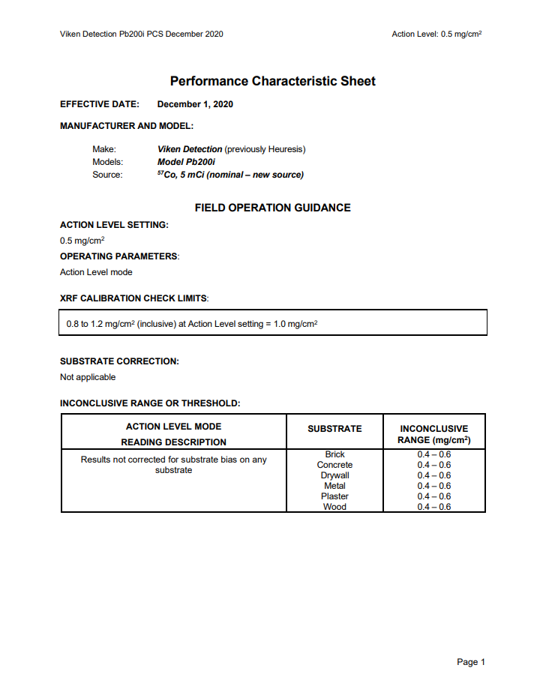

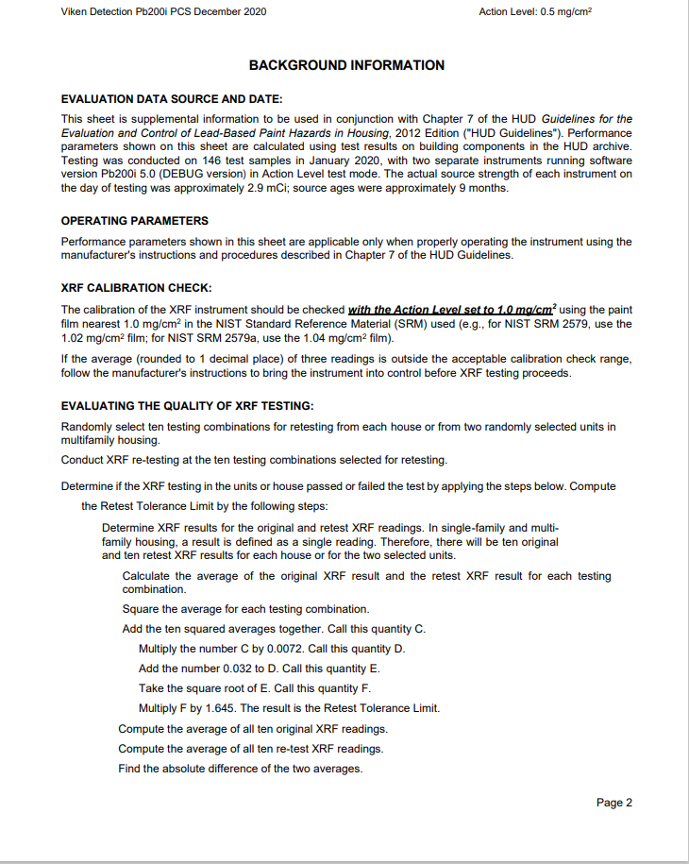

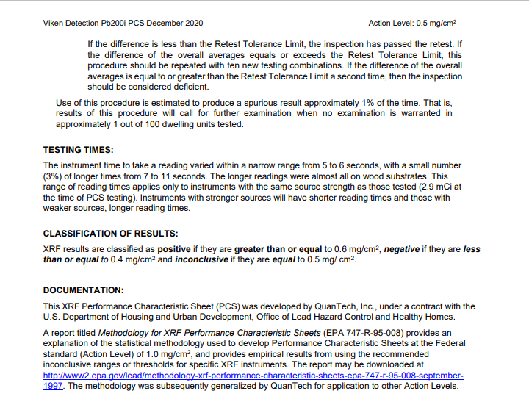
Pre-risk assessment calibration readings

Reading # | Concentration | Units
Click or tap to enter concentration | Click or tap to enter concentration | mg/cm²
Click or tap to enter concentration | Click or tap to enter concentration | mg/cm²
Click or tap to enter concentration | Click or tap to enter concentration | mg/cm²

Post-risk assessment calibration readings

Reading # | Concentration | Units
Click or tap to enter concentration | Click or tap to enter concentration | mg/cm²
Click or tap to enter concentration | Click or tap to enter concentration | mg/cm²
Click or tap to enter concentration | Click or tap to enter concentration | mg/cm²

Appendix B: Laboratory Analysis Report(s)

Appendix C: Floor Plan(s) and Site Sketch

Appendix D: Pictures

Appendix E: Ongoing Monitoring
It's unusual to remove all lead-based paint (LBP) from the property. This means that new hazards can develop when:
- Control measures fail (for example, damage to an enclosure).
- LBP becomes deteriorated.
- Dust from friction, impact, or other deterioration collects on floors or windowsills.
- Contaminated dust and soil from outside are tracked inside.
To keep the house safe, the owner should:
- Visually assess for hazards at least once a year after the risk assessment or controlling hazards.
- Hire a certified lead risk assessor for a reevaluation of the property every two years.

Visual Assessment
Who can do it
The owner of the property (or their agent).

When to do it
Start annual visual assessments one year after the risk assessment or any hazard reduction work. Also do one when:
- A resident reports deteriorated paint or other possible lead hazards.
- A unit becomes vacant (assess before re-renting it).
- A unit sustains damage (for example, flooding, wind, fire).

How to do it
Go through the dwelling unit and each common area. Including exterior painted surfaces and ground cover. Check for:
- Deterioration on any untested surfaces and surfaces with known LBP.
- Structural problems that could make LBP or untested paint fail.
- Continued integrity of enclosures and encapsulants used to control LBP hazards.

Reevaluation
Who can do it
A certified lead risk assessor.

When to do it
Start biennial reevaluations two years after the risk assessment or any hazard reduction work. Then, reevaluate every two years (plus or minus 60 days). If two consecutive reevaluations find no LBP hazards, you can stop doing them.

How it is done
A reevaluation is a risk assessment that builds on a previous investigation report. If hazards were controlled after a previous risk assessment, the risk assessor makes sure they are still effective. Then, the risk assessor identifies any new LBP hazards by:
- Looking for deteriorated paint. If that paint wasn't already tested, the risk assessor tests it.
- Looking for other potential hazards, such as new bare soil and friction surfaces.
- Collecting new dust wipe samples and soil samples (if there is new bare soil).
The risk assessor compiles information on all LBP hazards into a written risk assessment report. The risk assessor also recommends options for controlling all LBP hazards.

The very small amount is the de minimis amount under the HUD Lead-safe Housing Rule (24 CFR 35.1350(d)), or the amount of paint that is not “paint in poor condition” under the EPA lead training and certification (“402”) rule (40 CFR 745.223).
Wisconsin law is less restrictive, defining any paint or any other surface coating material containing more than 1 milligram of lead per square centimeter in the dried film of applied paint, as lead-based paint. The federal definition is used here to assure compliance with both state and federal law.
Wisconsin law is less restrictive, defining any paint or any other surface coating material containing more than 1 milligram of lead per square centimeter in the dried film of applied paint, as lead-based paint. The federal definition is used here to assure compliance with both state and federal law.
www.dhs.wisconsin.gov/lead/index.htm
Wis. Admin Code DHS Chapter 163 https://docs.legis.wisconsin.gov/code/admin_code/dhs/110/163/Title
www.epa.gov/lead/protect-your-family-lead-your-home-real-estate-disclosure
HUD Guidelines for the Evaluation and Control of Lead-Based Paint Hazards is Housing (2012 Edition) www.hud.gov/program_offices/healthy_homes/lbp/hudguidelines
Appendix 13.1: Wipe Sampling of Settled Dust for Lead Determination www.hud.gov/sites/documents/LBPH-40.PDF
Appendix 13.3: Collecting Soil Samples for Lead Determination www.hud.gov/sites/documents/LBPH-42.PDF
Appendix 13.3: Collecting Soil Samples for Lead Determination www.hud.gov/sites/documents/LBPH-42.PDF
eCFR :: 40 CFR Part 745 -- Lead-Based Paint Poisoning Prevention in Certain Residential Structures https://www.ecfr.gov/current/title-40/chapter-I/subchapter-R/part-745#745.63
eCFR :: 40 CFR Part 745 -- Lead-Based Paint Poisoning Prevention in Certain Residential Structures https://www.ecfr.gov/current/title-40/chapter-I/subchapter-R/part-745#745.63

