Department of Health Services |  |  |  | State of Wisconsin
Division of Public Health  F-44063 (04/2025) |  |  |  | Wis. Adm. Code ch. DHS 163  Page 1 of 2

Lead Principal Instructor Application
Instructions: Complete this form to apply for approval as a principal instructor for lead training. This application is for people who are already certified in a lead discipline, or who are enclosing their certification application.

Your Information
Name – First |  | Middle |  |  |  |  | Last name(s)
Address
City |  |  |  |  |  | State |  |  | ZIP code
Phone number |  |  |  | Email
Approval Type and Fees
Check the set of courses you are applying to instruct and include a check or money order payable to DHS.
Type of approval | Certification required |  | Courses you may teach |  |  |  |  | Initial fee |  | Renewal fee
Lead Hazard Reduction | Lead Abatement Supervisor |  | Lead-Safe Renovator, Abatement Worker, and Abatement Supervisor |  |  |  |  | $100 |  | $50
Lead Investigation | Lead Risk Assessor |  | Lead Sampling Technician, Inspector, Hazard Investigator, and Risk Assessor |  |  |  |  | $100 |  | $100
Additional Requirements for Initial Applicants
If this is your first time applying for principal instructor approval, you must complete the Training and Experience section on page 2.
Signature
I verify that the information submitted on this application is truthful and accurate. I understand that any false information provided may be grounds for denying or revoking my certification. I understand that I must comply with Wisconsin lead regulations.
Signature |  |  |  |  |  |  | Date
Submit Application
Mail your completed application, fee, and all required attachments to:
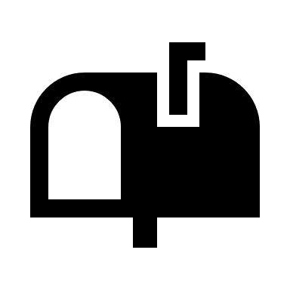
State of Wisconsin
PO Box 93419
Milwaukee, WI 53293-3419

If you have questions, call (608) 261-6876.
If you prefer a call in a language other than English, please email DHSAsbestosLead@dhs.wisconsin.gov to request an interpreter.

Training and Experience for Initial Applicants
Initial applications must complete the additional requirements below.
Include one of the following:
Teaching methods certificate – at least a 16-hour train-the-trainer course certificate or equivalent training, including course description or agenda.
College transcript – coursework in educational methods.
If applying for lead investigation approval, include proof of XRF training.
Complete the following sections about your experience.
Instruction Experience
To be qualified for instructor approval, you must show that you have one year of experience providing work-related instruction in the last 5 years. List the organization, dates, and a description of the instruction, along with one contact who can confirm your experience.
Organization | Start date |  | End date
Contact name |  | Contact email
Description of instruction

Experience Related to Lead Hazard Reduction or Investigation
To be qualified for instructor approval, you must show that you have one year of experience related to lead hazard reduction or lead investigation in the last 5 years. The experience must include direct responsibility for the activities described below (or similar).
Lead Hazard Reduction |  | Lead Investigation
- Construction, improvement, or repair of homes or other buildings  - Lead worker protection or lead health effects  - Hazardous material abatement  - Environmental regulations |  | - Construction, improvement, or repair of homes or other buildings  - Environmental investigations, building inspections, or hazard identification  - Public health or lead health effects  - Environmental regulations
List the organization, dates, and activities for which you were directly responsible, along with one contact who can confirm your experience.
Organization | Start date |  | End date
Contact name |  | Contact email
Description of activities

