DEPARTMENT OF HEALTH SERVICES STATE OF WISCONSIN
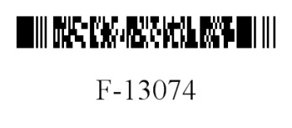
Division of Medicaid Services
F-13074 (04/2014)

FORWARDHEALTH
PHARMACY SPECIAL HANDLING REQUEST

Instructions: Providers may submit the Pharmacy Special Handling Request and paper drug claim to ForwardHealth, Pharmacy Special Handling Unit, Suite 20, 313 Blettner Boulevard, Madison, WI 53784. Type or print clearly. Refer to the Pharmacy Special Handling Request Completion Instructions, F-13074A, for more information.

SECTION I — PROVIDER INFORMATION
1. National Provider Identifier | 2. Telephone Number — Provider
3. ForwardHealth Program
Wisconsin Medicaid.
BadgerCare Plus Standard Plan.
SeniorCare.
Wisconsin Chronic Disease Program.
SECTION II — REASON FOR REQUEST (Choose one.)
4. Policy Review Request (In the space below, include the Explanation of Benefits (EOB) number, reason for policy review, and any additional information.)

5. Emergency Supply Request (In the space below, include the type of prior authorization (PA), Internal Control Number, EOB number, and any additional information.)

Indicate the type of PA request from the options listed:
Brand Medically Necessary.
Clinical PA / Diagnosis Restriction.
Preferred Drug List.

SECTION III — CERTIFICATION
6. SIGNATURE — Pharmacist or Dispensing Physician |  | 7. Date Signed

