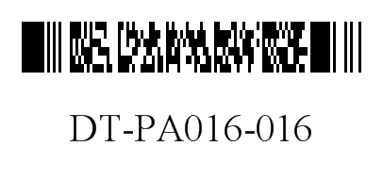
DEPARTMENT OF HEALTH SERVICES STATE OF WISCONSIN
Division of Medicaid Services Wis. Admin. Code § DHS 106.03(4)
F-11035 (06/2024) Wis. Admin. Code § DHS 152.06(3)(h)

FORWARDHEALTH
PRIOR AUTHORIZATION DENTAL REQUEST FORM (PA/DRF)

INSTRUCTIONS: Type or print clearly. Before completing this form, read the Prior Authorization Dental Request Form (PA/DRF) Instructions, F-11035A. Providers may submit PA requests by fax to ForwardHealth at 608-221-8616 or by mail to: ForwardHealth, Prior Authorization, Suite 88, 313 Blettner Boulevard, Madison, WI 53784.

SECTION I – PROVIDER INFORMATION
1. Check only if applicable  HealthCheck “Other Services”  Wisconsin Chronic Disease Program |  |  |  |  |  | 2. Process Type (Check one)  124 (Dental)  125 (Ortho)
3. Name and Address – Billing Provider (Street, City, State, Zip+4 Code)

4. Phone Number – Billing Provider |  |  |  |  |  | 5a. Billing Provider Number
5b. Billing Provider Taxonomy Code |  |  |  |  |  | 6a. Rendering Provider Number
6b. Rendering Provider Taxonomy Code |  |  |  |  |  | 7. Requested Start Date
8. Name – Contact Person (Staff Member Filling Out This Form) |  |  |  |  |  |  | 9. Phone Number – Contact Person

SECTION II – MEMBER INFORMATION
10. Member ID Number |  |  | 12. Address – Member (Street, City, State, Zip+4 Code)

11. Date of Birth – Member

13. Name – Member (Last, First, Middle Initial) |  |  |  |  |  |  |  |  | 14. Gender – Member  Male Female

SECTION III – DIAGNOSIS / TREATMENT INFORMATION
15. Place of Service (POS)
Dental Office (POS Code 11)
Outpatient Hospital (POS Code 22)
Ambulatory Surgical Center (POS Code 24)
Skilled Nursing Facility (POS Code 31)
Other (Specify):
16. Dental Diagram  - Check periodontal case type if applicable.  I  II  III  IV  V  - Cross out missing teeth.  - Circle teeth to be extracted. |  |  |  |  |  | 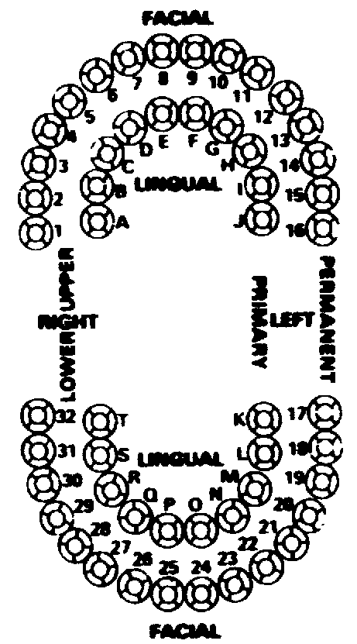 |  | Staple X-Ray Envelope Here  Number of X-rays  Type of X-rays
17.  Area of Oral Cavity | 18.  Tooth | 19.  Procedure Code |  | 20.  Modifier | 21.  Description of Service |  |  |  | 22.  Quantity Requested | 23.  Charge
 |  |  |  |  |  |  |  |  | 24. Total Charges
An approved authorization does not guarantee payment. Reimbursement is contingent upon enrollment of the member and provider at the time the service is provided and the completeness of the claim information. Payment will not be made for services initiated prior to approval or after the authorization expiration date. Reimbursement will be in accordance with ForwardHealth payment methodology and policy. If the member is enrolled in a BadgerCare Plus managed care program at the time a prior authorized service is provided, ForwardHealth reimbursement will be allowed only if the service is not covered by the managed care program.
25. SIGNATURE – Rendering Provider |  |  |  |  |  |  |  |  | 26. Date Signed
27. SIGNATURE – Member / Guardian (if applicable) |  |  |  |  |  |  |  |  | 28. Date Signed

