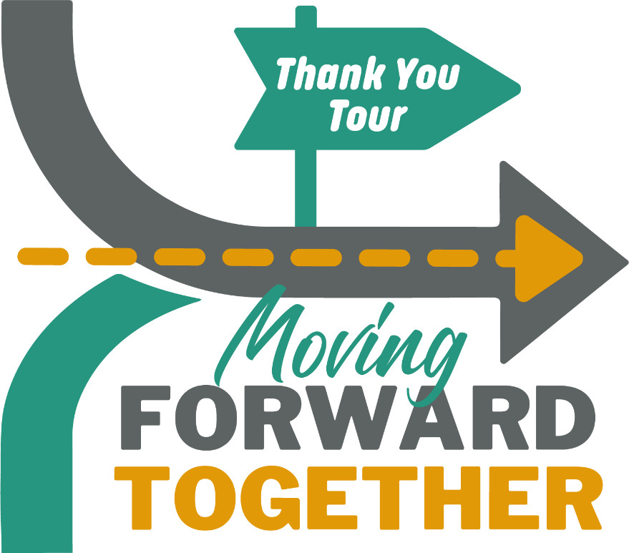
Join us, in partnership with the Wisconsin Department of Health Services to recognize and thank our community for its COVID-19 response efforts.
<date>
<time>
<location>
State and local leaders want to see and hear directly from you!
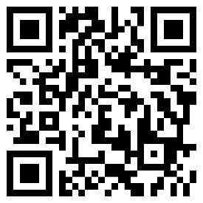
Help us recognize those on the COVID-19 frontlines.
Take part in the statewide recognition by thanking someone for their service and leadership in support of the COVID-19 response by visiting dhs.wisconsin.gov/thankyou.
DHS will share messages on its website and social media platforms as appropriate.

