Help the Birth to 3 Program reach Wisconsin children and families
As families across Wisconsin face uncertainties during the COVID-19 (coronavirus) pandemic, services for children with delays or disabilities is still a critical need for families.
That’s why the Wisconsin Department of Health Services (DHS) is reaching out to families, providers, physicians, and other health and child care professionals with a reminder to continue referring any child under the age of 3 to the Birth to 3 Program if they have concerns about a child’s growth and development.
We have seen a decrease in referrals since the beginning of the COVID-19 pandemic, and we want to make sure children and families are getting the support and services they need. The Birth to 3 Program continues to provide services, with families and Individualized Family Service Plan teams working together to find the best ways to stay in contact and continue, or start, services.
DHS would like your help sharing this message. This media toolkit includes resources you can use to support continued referrals to the Birth to 3 Program, and to spread the word that we are providing continuous support throughout these uncertain times. All materials are currently available electronically to facilitate fast and versatile application.
Thank you for your consideration,
Wisconsin Department of Health Services

Media Toolkit Resources Overview
Each professional association has its own approach for sharing information with members. DHS invites you to share any or all information here in a way that fits the needs of your membership. All the resources you need are included below.
Available resources | How to use resources | Where to access resources
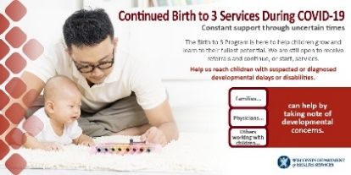  Social media posts for Facebook, Twitter, and Instagram | - Share on your social media channels on a regular rotation to support Child Find efforts and drive Birth to 3 referrals.  - Share directly from DHS feeds. | - The social media graphic, in English and Spanish, is included in this packet.  - Sample social media posts in English and Spanish are included in this packet.  - Relevant posts can be found on DHS social media accounts.  - Facebook: @DHSWI  - Twitter: @DHSWI  - Instagram: @DHS.WI
Flyer  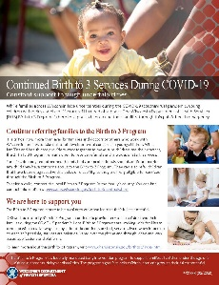 | Use this flyer to encourage referrals and create awareness of continued Birth to 3 Program services through the COVID-19 pandemic.  - Share on your website.  - Include with a newsletter article.  - Distribute electronically to physicians and clinics.  - Send electronically to families. | - Access and download an English version PDF of this flyer.  - Access and download a Spanish version PDF of this flyer.  - Access and download a Hmong version PDF of this flyer.
Newsletter Articles  - Provider/physician-focused article to drive referrals  - Family-focused article to communicate continued services | These newsletter articles help remind providers, physicians, and other health and child care professionals to make referrals to the Birth to 3 Program and create awareness of continued services through the COVID-19 pandemic.  - Share on your website.  - Publish in your next newsletter. | - Sample articles are included in this packet.

Social Media Posts
Below is content you can post to your Facebook, Twitter, and Instagram pages about Birth to 3 Program services throughout the COVID-19 pandemic.
You can also follow DHS on social media and share these posts directly from our feed:
- Facebook: @DHSWI
- Twitter: @DHSWI
- Instagram: @DHS.WI

Social Media Visual
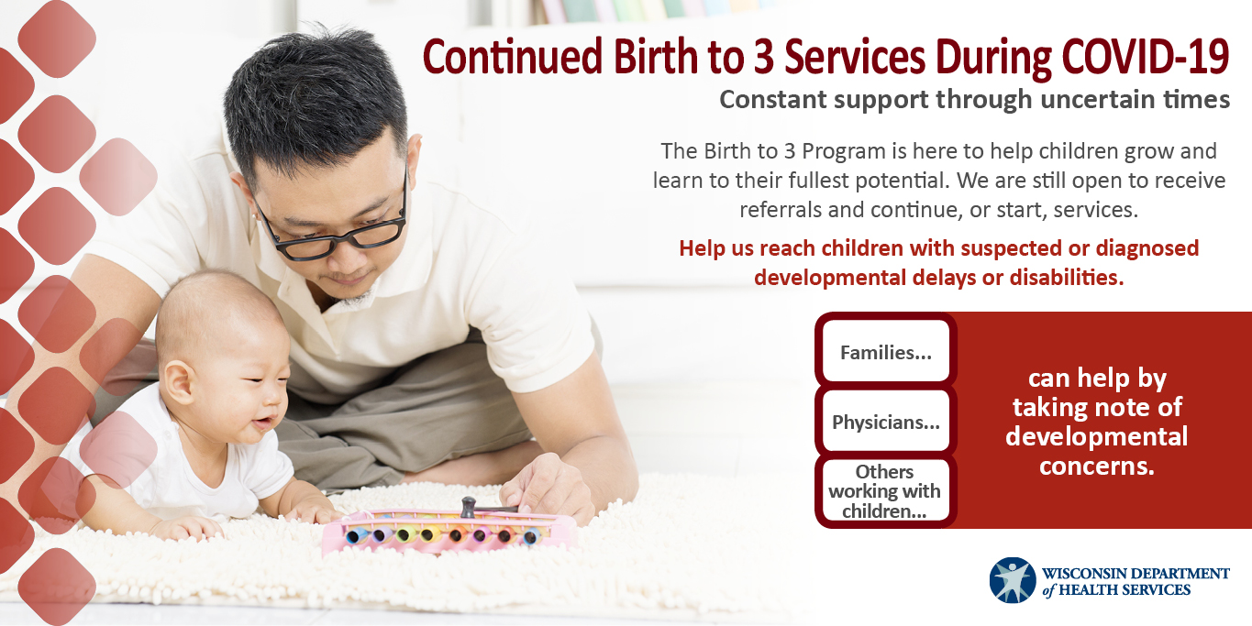
English

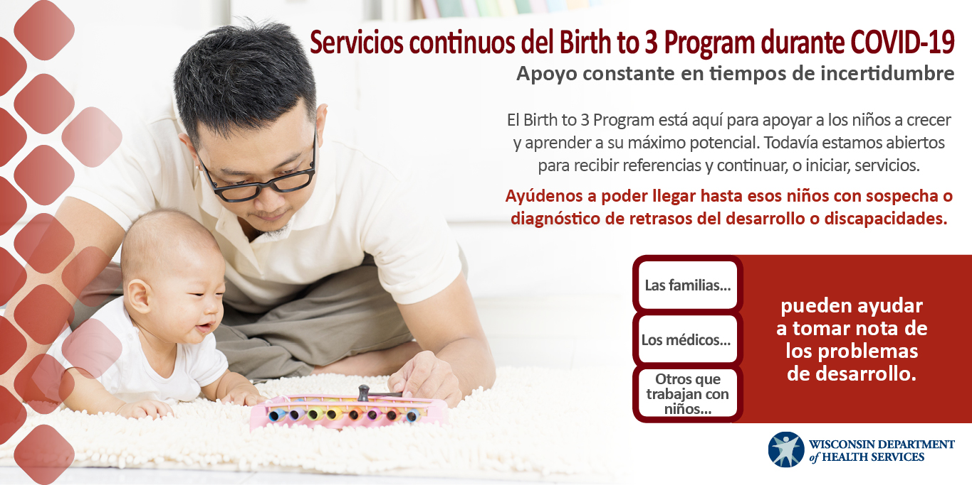
Spanish
Download these images to your computer.
- Right click on the image.
- Choose Save As Picture from the dropdown menu.
- Name the image and save it as a .jpg file on your computer.
- Upload the image from your computer into a social media post.
Example Facebook and Instagram posts:
Post 1 English: The #DHSWI Birth to 3 Program is here for Wisconsin families, even during #COVID19. Doctors and others that work with children should continue referring children with suspected or diagnosed delays or disabilities to the right local program for each family. Contact information for local programs can be found at www.dhs.wisconsin.gov/birthto3/contacts.htm.
Post 1 Spanish: El #DHSWI Birth to 3 Program está aquí para apoyar a las familias de Wisconsin, incluso durante #COVID19. Los médicos y otras personas que trabajan con niños deben continuar refiriendo a los niños con sospecha o diagnóstico de retrasos del desarrollo o discapacidades al programa local adecuado para cada familia. La información de contacto de los programas locales se puede encontrar en www.dhs.wisconsin.gov/birthto3/contacts.htm.
Post 2 English: As families across Wisconsin face uncertainties during #COVID19, children with delays or disabilities still need support to learn and grow to their full potential. The #DHSWI Birth to 3 Program is providing continuous service through this pandemic. If parents, doctors or others who work with children have concerns about a child’s development, they can refer them to a local Birth to 3 Program at www.dhs.wisconsin.gov/birthto3/contacts.htm.
Post 2 Spanish: Mientras que las familias en todo Wisconsin se enfrentan a incertidumbres durante #COVID19, los niños con retrasos o discapacidades aún necesitan apoyo para aprender y crecer a su máximo potencial. El programa #DHSWI Birth to 3 Program continúa proporcionando servicios durante esta pandemia. Si los padres, los médicos u otras personas que trabajan con niños tienen preocupaciones sobre el desarrollo de un niño, pueden referirlos a un programa local del Birth to 3 Program en www.dhs.wisconsin.gov/birthto3/contacts.htm.
Post 3 English: Children may be missing school, doctor’s appointments, and daycare during #COVID19, so it is more important than ever for parents to notice signs of delays or disabilities. If parents have concerns about their child, they should schedule a well-child check with their doctor today. Children age 3 or under may be referred for services through the Birth to 3 Program. Learn more at www.dhs.wisconsin.gov/birthto3/index.htm.

Post 3 Spanish: Los niños pueden estar faltando a la escuela, a las citas con el médico y a la guardería durante el #COVID19, por lo que es más importante que nunca que los padres noten los signos de retrasos o discapacidades en sus hijos. Si los padres tienen preocupaciones sobre sus hijos, deben programar una consulta de chequeo general para el niño con su médico hoy mismo. A los niños de 3 años o menos se les puede referir para que reciban servicios a través del Birth to 3 Program. Obtenga más información en www.dhs.wisconsin.gov/birthto3/index.htm.

Example Tweets:
Tweet 1 English: The #DHSWI Birth to 3 Program is here for families, even during #COVID19. Be sure to continue referring children with suspected or diagnosed delays or disabilities to the local program in their county at www.dhs.wisconsin.gov/birthto3/contacts.htm.
Tweet 1 Spanish: El #DHSWI Birth to 3 Program está aquí para apoyar a las familias, incluso durante #COVID19. Asegúrese de seguir refiriendo a los niños con sospecha o diagnóstico de retrasos o discapacidades al programa local de su condado en www.dhs.wisconsin.gov/birthto3/contacts.htm.
Tweet 2 English: As families deal with #COVID19, support for children with delays or disabilities is still a priority for the Birth to 3 Program. If you have concerns about a child’s development, refer them today. www.dhs.wisconsin.gov/birthto3/contacts.htm
Tweet 2 Spanish: Mientras las familias se ocupan de #COVID19, el apoyo a los niños con retrasos o discapacidades sigue siendo una prioridad para el Birth to 3 Program. Si tiene preocupaciones sobre el desarrollo de un niño, refiéralos hoy mismo. www.dhs.wisconsin.gov/birthto3/contacts.htm.
Tweet 3 English: Kids may be missing appointments during #COVID19, but parents should schedule a well-child check if they have concerns about their child’s development. Kids 3 or under could get support from the Birth to 3 Program: www.dhs.wisconsin.gov/birthto3/index.htm.

Tweet 3 Spanish: Los niños pueden estar faltando a sus citas durante #COVID19, pero los padres deben programar un chequeo general para el niño si tienen preocupaciones sobre el desarrollo de su hijo. Los niños de 3 años o menos podrían recibir apoyo del Birth to 3 Program: www.dhs.wisconsin.gov/birthto3/index.htm.

Newsletter Articles
Consider communicating about continued services during COVID-19 and reminding your audiences to keep making referrals in your organization’s next newsletter. Copy and paste text from the choices below to help develop an article. Text tailored to different audiences is provided so your association can select content that best meets the needs of your membership.

(Length: Title + 138 words) Short article for audiences including providers, physicians, and other professionals working directly with families and children.
Continue referring families to the Birth to 3 Program
The Birth to 3 Program continues to find creative ways to connect with families and children and to adapt supports and services based on unique and unexpected circumstances. During the COVID-19 pandemic, it is more critical than ever to help ensure that Wisconsin’s children get the services they need.
The Wisconsin Department of Health Services (DHS) would like to remind you that many children under the age of 3 with delays or disabilities can receive support and services from the Birth to 3 Program.
Please continue to refer any child to the Birth to 3 Program who displays signs of a delay or disability. You can also refer children that have been diagnosed with a delay or disability, as they are likely eligible for services.
To refer a child to Birth to 3 Program services, contact your county.
(Length: Title + 183 words) Short article for audiences including families and caregivers.
Do you have a young child with a delay or disability? The Birth to 3 Program is here to support you.
While families face uncertainties during the COVID-19 (coronavirus) pandemic, young children with delays or disabilities are still in need of support. The Wisconsin Department of Health Services (DHS) Birth to 3 Program is here to support children and their families through this public health emergency.
The Birth to 3 Program strives to help children grow and learn to their fullest potential. Families of children with developmental delays or disabilities under the age of 3 can get support and services from the program.
DHS and local county Birth to 3 Programs are able to adapt supports and services to the unique challenges each family and community is facing. Individualized Family Support Plan (IFSP) teams and families work together to find the best way to stay in touch during this time. When in-person contact isn’t possible, services are delivered over the phone and through online video applications (apps) and platforms. Everyone works to make sure children get the support and services they need at all times.
If you believe your child has a delay or disability, or has been diagnosed with one, contact your county.

